## EFFICIENT FINANCE RECEIPTING THROUGH ROBOTIC PROCESS AUTOMATION WORKFLOW DESIGN

## A PROJECT REPORT

***Submitted by,***

**M ABHISHEK - 20211ISR0048**

**M D SAILESH - 20211ISR0044**

**K SRIHARI - 20211ISR0046**

**TUSHAR SAGORE - 20211ISR0024**

### *Under the guidance of,*

**Dr. Sasidhar Babu Suvanam**

***Professor***

***in partial fulfillment for the award of the degree of***

**BACHELOR OF TECHNOLOGY**

**IN**

**INFORMATION SCIENCE AND ENGINEERING**

**(ARTIFICIAL INTELLIGENCE AND ROBITICS)**

**At**



**PRESIDENCY UNIVERSITY**

**BENGALURU**

**January 2025**

**PRESIDENCY UNIVERSITY**

**SCHOOL OF COMPUTER SCIENCE ENGINEERING**

**CERTIFICATE**

This is to certify that the Project report **“EFFICIENT FINANCE RECEIPTING THROUGH ROBOTIC PROCESS AUTOMATION WORKFLOW DESIGN”** being submitted by “M Abhishek, k Srihari, M D Sailesh, Tushar Sagore” bearing roll number(s) “20211ISR0048, 20211ISR0046, 20211ISR0044, 20211ISR0024” in partial fulfillment of the requirement for the award of the degree of Bachelor of Technology in Information Science and Engineering is a bonafide work carried out under my supervision.

|  |  |
| --- | --- |
| **Dr Sasidhar Babu Suvanam**  Professor & Guide  School of CSE&IS  Presidency University | **Dr. Zafar Ali Khan**  Professor & HOD  School of CSE&IS  Presidency University |

|  |  |  |
| --- | --- | --- |
| **Dr. L. SHAKKEERA**  Associate Dean  School of CSE&IS  Presidency University | **Dr. MYDHILI NAIR**  Associate Dean  School of CSE&IS  Presidency University | **Dr. SAMEERUDDIN KHAN**  Pro-VC School of Engineering  Dean -School of CSE&IS  Presidency University |

**PRESIDENCY UNIVERSITY**

**SCHOOL OF COMPUTER SCIENCE ENGINEERING**

**DECLARATION**

We hereby declare that the work, which is being presented in the project report entitled **EFFICIENT FINANCE RECEIPTING THROUGH ROBOTIC PROCESS AUTOMATION WORKFLOW DESIGN** in partial fulfillment for the award of Degree of **Bachelor of Technology** in **Information Science and Engineering**, is a record of our own investigations carried under the guidance of **Dr.** **Sasidhar Babu Suvanam, Professor,** **School of Computer Science Engineering & Information Science, Presidency University, Bengaluru.**

We have not submitted the matter presented in this report anywhere for the award of any other Degree.

|  |  |  |
| --- | --- | --- |
| **Name** | **Roll No** | **Signature** |
| **M Abhishek** | **20211ISR0048** |  |
| **K Sri Hari** | **20211ISR0046** |  |
| **M D Sailesh** | **20211ISR0044** |  |
| **Tushar Sagore** | **20211ISR0024** |  |

**ABSTRACT**

This project explores the implementation of Robotic Process Automation (RPA) using UiPath to revolutionize the finance receipting process. Traditional methods of handling financial receipts—such as manual data entry, template population, and email dispatch—are labor-intensive, error-prone, and inefficient, especially for businesses managing high transaction volumes. This project proposes a comprehensive automation solution to address these challenges by streamlining and standardizing the end-to-end receipting workflow. The RPA solution begins with the extraction of transaction data from an Excel file, including details such as receipt numbers, customer information, and payment amounts. This data is automatically populated into a predefined credit card receipt template, ensuring consistency and accuracy in receipt generation. Each receipt is then saved as a unique file in organized folders based on business-specific conventions, facilitating systematic record-keeping. Finally, the system automates the email distribution process, attaching the appropriate receipt and sending it directly to the customer’s email address.

Key objectives of the project include enhancing operational efficiency, reducing human errors, and improving scalability. The automation significantly reduces processing time, enabling businesses to handle large transaction volumes with minimal human intervention. Additionally, robust error-handling mechanisms ensure the system’s reliability, logging exceptions such as missing data or incorrect email addresses for review. By eliminating repetitive tasks, the project also enables employees to focus on higher-value activities, thus increasing overall productivity. The outcomes of this project demonstrate the transformative potential of RPA in financial workflows. Businesses benefit from timely and accurate receipting, improved customer satisfaction, and reduced operational costs. Furthermore, the system is scalable and adaptable, capable of accommodating future changes in templates, data formats, or business requirements. This implementation highlights how automation can optimize back-office financial operations, providing a secure, efficient, and future-ready solution for receipting tasks.

**ACKNOWLEDGEMENT**

First of all, we indebted to the **GOD ALMIGHTY** for giving me an opportunity to excel in our efforts to complete this project on time.

We express our sincere thanks to our respected **Dr. Md. Sameeruddin Khan**, Pro-VC, School of Engineering and Dean, School of Computer Science Engineering & Information Science, Presidency University for getting us permission to undergo the project.

We express our heartfelt gratitude to our beloved Associate Deans **Dr. Shakkeera L and Dr. Mydhili Nair,** School of Computer Science Engineering & Information Science, Presidency University, and **Dr. “Zafar Ali Khan**”, Head of the Department, School of Computer Science Engineering & Information Science, Presidency University, for rendering timely help in completing this project successfully.

We are greatly indebted to our Guide **Dr. Sasidhar Babu Suvanam,** **Professor** and Reviewer **Dr.** **Zafar Ali Khan, Professor,** School of Computer Science Engineering & Information Science, Presidency University for his/her inspirational guidance, and valuable suggestions and for providing us a chance to express our technical capabilities in every respect for the completion of the project work.

We would like to convey our gratitude and heartfelt thanks to the PIP2001 Capstone Project Coordinators **Dr. Sampath A K, Dr. Abdul Khadar and Mr. Md Zia Ur Rahman,** department Project Coordinators **Dr. Afroz pasha** and Git hub coordinator **Mr. Muthuraj.**

We thank our family and friends for the strong support and inspiration they have provided us in bringing out this project.

**M Abhishek  
K Srihari   
M D Sailesh  
Tushar Sagore**

**TABLE OF CONTENTS**

|  |  |  |
| --- | --- | --- |
| **CHAPTER NO.** | **TITLE** | **PAGE NO.** |
|  | **ABSTRACT ACKNOWLEDGMENT** | **iv**  **v** |
| **1.** | **INTRODUCTION** | 1 |
| **2.** | **LITERATURE REVIEW** | 2 |
| **3.** | **RESEARCH GAPS OF EXISTING METHODS** | 4 |
| **4.** | **PROPOSED METHODOLOGY** | 7 |
| **5.** | **OBJECTIVES** | 19 |
| **6.** | **SYSTEM DESIGN & IMPLEMENTATION** | 20 |
| **7.** | **TIMELINE FOR EXECUTION OF PROJECT (GANTT CHART)** | 39 |
| **8.** | **OUTCOMES** | 40 |
| **9.** | **RESULTS AND DISCUSSIONS** | 41 |
| **10** | **CONCLUSION** | 43 |
|  | **REFERENCES** | 44 |

**CHAPTER-1**

**INTRODUCTION**

Financial receipting is an essential aspect of business operations, particularly for organizations handling high volumes of transactions. The process involves recording transaction data, generating accurate receipts, storing them systematically, and delivering them promptly to customers. Traditionally, this workflow has relied on manual methods, where employees handle data entry, populate templates, and manage file storage and communication. While this approach suffices for businesses with low transaction volumes, it becomes increasingly inefficient and error-prone as the scale of operations grows. Common issues, such as delayed processing, misplaced records, or inaccuracies in data entry, often disrupt workflows and impact customer satisfaction.

In today’s competitive business environment, there is a growing need for solutions that enhance efficiency, accuracy, and scalability in financial operations. The manual processes used in financial receipting are not only time-consuming but also susceptible to human error, leading to inconsistencies in records and delays in customer communication. This inefficiency can result in dissatisfied clients and compliance risks, particularly when dealing with sensitive customer data such as credit card information and transaction records.

Robotic Process Automation (RPA) offers a transformative solution to address these challenges. RPA uses software bots to replicate human actions, enabling the automation of repetitive, rule-based tasks with high precision and speed. In the context of financial receipting, RPA can automate the entire workflow, from extracting transaction data from an Excel sheet to populating receipt templates, organizing files systematically, and emailing receipts to customers. This eliminates the need for manual intervention, ensuring consistent, accurate, and timely receipting.

This project focuses on implementing an RPA solution using UiPath to automate the finance receipting process. The proposed solution is designed to extract transaction details from structured Excel files, dynamically populate a predefined credit card receipt template, save the generated receipts in an organized folder structure, and dispatch them to customers via email. By automating these repetitive tasks, the project aims to significantly reduce processing time, enhance data accuracy, and improve operational efficiency.

**CHAPTER-2**

**LITERATURE SURVEY**

The automation of financial processes has gained significant attention in recent years due to the increasing demand for efficiency, accuracy, and scalability in handling large transaction volumes. As businesses continue to expand and digitize their operations, manual processes such as receipting, invoicing, and data entry have become increasingly impractical and error-prone. Robotic Process Automation (RPA) has emerged as a transformative technology, offering a reliable solution to streamline repetitive tasks, reduce human intervention, and enhance operational performance. Numerous studies have explored the adoption of RPA in financial workflows, highlighting its profound impact on reducing errors, optimizing resource utilization, and improving overall efficiency.

A comprehensive study conducted by Deloitte (2023) sheds light on the growing role of RPA in revolutionizing financial operations. The research highlights that businesses leveraging RPA have achieved a 70% reduction in processing time while significantly enhancing data accuracy. This underscores RPA's ability to minimize human error, especially in tasks that require high levels of precision, such as data extraction, receipt generation, and transaction reconciliation. The study also emphasizes that RPA enables businesses to reallocate resources to more strategic activities, thus improving productivity and value generation.

Similarly, a report published by Ernst & Young (2022) delves into the advantages of RPA in automating financial receipting workflows. The report notes that RPA’s ability to integrate seamlessly with existing systems, such as Enterprise Resource Planning (ERP) software and Customer Relationship Management (CRM) platforms, is a key factor driving its adoption. This seamless integration not only ensures compliance with regulatory requirements but also facilitates end-to-end automation of financial processes, reducing manual intervention and operational bottlenecks. The research further highlights that organizations using RPA for receipting have observed a significant improvement in customer satisfaction due to the timely and accurate delivery of financial documents.

Extensive research on RPA tools like UiPath has demonstrated their effectiveness in automating complex financial workflows. UiPath’s capabilities in handling structured data from Excel, dynamically populating templates, and automating email dispatch make it a preferred choice for implementing RPA solutions in finance. Case studies published by UiPath illustrate successful deployments in organizations managing thousands of daily transactions. These implementations have resulted in improved operational efficiency, reduced processing costs, and enhanced data accuracy. Furthermore, UiPath’s user-friendly interface and extensive library of pre-built activities allow businesses to customize workflows to meet their unique requirements, making it a versatile tool for financial automation.

The role of pre-built automation templates and AI-driven enhancements in modern RPA platforms has also been explored extensively in recent literature. These features enable the automation of more sophisticated workflows, such as dynamic template filling, intelligent data extraction, and advanced error handling. A report by Gartner (2022) emphasizes that organizations leveraging advanced RPA tools achieve greater scalability, adaptability, and resilience in their financial processes. For example, AI-driven enhancements allow RPA bots to handle unstructured data and make decisions based on predefined rules, further expanding the scope of automation in financial operations.

Despite the numerous benefits of RPA, several challenges remain that need to be addressed for its successful implementation. Data security is a critical concern, as financial processes often involve sensitive customer information, such as credit card details and transaction records. Ensuring compliance with data protection regulations, such as GDPR and PCI DSS, is essential to maintain customer trust and avoid legal repercussions. Additionally, integrating RPA with legacy systems can pose technical challenges, particularly in organizations with outdated infrastructure. Scalability is another area of focus, as businesses must ensure that their RPA solutions can handle increasing transaction volumes without compromising performance or reliability.

Studies also highlight the importance of robust error-handling mechanisms and compliance frameworks to ensure seamless operation in live environments. For example, workflows must be designed to detect and address issues such as missing data, system downtime, or invalid inputs without disrupting the overall process. By incorporating exception-handling logic and real-time monitoring, businesses can enhance the resilience and reliability of their RPA implementations.

**CHAPTER-3**

**RESEARCH GAPS OF EXISTING METHODS**

**Manual Data Entry and Receipting**

Manual data entry and receipting are among the oldest and simplest methods for managing financial transactions. This process involves extracting relevant information from sales or transaction records, such as customer details, transaction IDs, payment amounts, and dates, and inputting these details into a predefined receipt template. Employees manually fill out the receipt form, which can then be printed for physical delivery or saved as a digital file to be emailed to the customer.This method is often employed by small businesses or organizations with low transaction volumes, as it requires minimal technological infrastructure. The templates used are typically created in software such as Microsoft Word or PDF editors, offering flexibility in formatting and customization. However, the manual nature of this process introduces several inefficiencies. Employees must handle each transaction individually, which increases the likelihood of errors such as incorrect data entry or missing information. Additionally, the time taken to complete each receipt limits the scalability of this method, making it impractical for businesses experiencing growth or handling high transaction volumes.Despite its limitations, manual data entry remains common in small-scale operations due to its simplicity and low implementation cost. Businesses that adopt this method often prioritize flexibility over efficiency, relying on human judgment to handle unique or complex transactions.

**Excel-Based Receipting**

Microsoft Excel is widely used by businesses to manage transaction data and generate receipts. Excel provides powerful tools for organizing data into structured tables, enabling businesses to maintain records of transactions efficiently. Receipt templates can be created in Excel, where transaction details such as receipt numbers, customer names, and payment amounts are manually or semi-automatically entered. One of the main advantages of Excel-based receipting is its ability to handle basic calculations and automate simple tasks using built-in formulas. For example, businesses can use Excel formulas to calculate totals, taxes, or discounts automatically, reducing the likelihood of mathematical errors. Additionally, Excel allows for data sorting and filtering, making it easier to retrieve specific transaction details when needed.

**Macro Automation in Excel**

Macros are scripts that can automate repetitive tasks in Excel, enhancing the efficiency of Excel-based receipting. By recording a sequence of actions, such as filling out a receipt template with transaction data or formatting cells, macros allow businesses to execute these tasks automatically with a single command. This method is particularly useful for businesses that handle similar types of transactions and require consistent formatting in their receipts.

For example, a macro can be programmed to extract transaction details from a specific row in an Excel sheet and populate them into a predefined receipt template. This reduces the manual effort required to transfer data and ensures consistency across receipts. Macros can also automate file-saving processes, assigning unique names to each receipt based on transaction details such as receipt numbers or customer names. While macros provide a degree of automation, they are not without limitations. Developing and maintaining macros requires some knowledge of programming languages like VBA (Visual Basic for Applications). Additionally, macros are highly dependent on the structure of the data and templates, making them prone to failure if there are changes in the input format or workflow. For businesses with complex or dynamic requirements, macros may not offer the flexibility needed to handle variations effectively.

**Basic Accounting Software**

Accounting software such as QuickBooks, FreshBooks, and Xero has become a popular choice for businesses looking to automate financial tasks, including receipting. These programs streamline the receipting process by automatically generating receipts based on transaction data entered into the system. Businesses can use accounting software to track sales, manage customer information, and issue receipts in a structured and consistent manner.One of the key advantages of accounting software is its ability to integrate multiple financial processes. For instance, when a transaction is recorded in the system, the software can automatically generate a receipt, update the financial records, and even send the receipt to the customer via email. Many accounting tools also include reporting features, allowing businesses to analyze their transaction data and gain insights into their financial performance

**Email-Based Receipting**

Email-based receipting involves generating receipts manually or semi-automatically and sending them to customers via email. In this method, businesses may use tools such as Microsoft Word or PDF editors to create receipts and then attach them to emails for delivery. Alternatively, software solutions that support email automation can be used to streamline the process. For businesses with moderate transaction volumes, email-based receipting provides a convenient way to communicate with customers and deliver receipts promptly. Some systems can trigger email dispatch automatically upon the completion of a transaction, reducing the time required to send receipts manually.

**Document Management Systems**

Document management systems (DMS) are used to store and organize digital receipts systematically. While these systems primarily focus on record-keeping, they are often integrated with receipting processes to ensure that receipts are automatically saved and categorized once generated.For example, a DMS can be configured to save receipts in specific folders based on transaction details such as dates, customer names, or receipt numbers. This improves the organization of financial records and simplifies retrieval during audits or customer inquiries.

**CHAPTER-4**

**PROPOSED METHODOLOGY**

**Methodology**

The methodology for this project is systematically organized into multiple stages, each tailored to ensure the effective implementation of a robust and scalable RPA solution for automating the finance receipting process. These stages—planning, requirement gathering, workflow design, development, testing, deployment, and integration—serve as a roadmap to transform traditional manual workflows into an automated system capable of handling repetitive tasks with precision and efficiency.

The process begins with planning, which establishes the foundation for the entire project by defining its scope, objectives, and expected outcomes. This stage ensures alignment with business goals and prepares a framework for subsequent steps. Following this, the requirement gathering phase involves a detailed analysis of the current manual receipting process. This includes identifying the structure of transaction data stored in Excel, understanding the fields and format of the receipt template, and defining key business rules such as file-naming conventions and folder structures. A thorough analysis of these elements helps in pinpointing inefficiencies and determining areas suitable for automation.

In the workflow design stage, the insights gathered are translated into a step-by-step blueprint for automation. This involves defining tasks such as reading transaction data from Excel, mapping it to corresponding fields in the receipt template, saving the completed receipts as organized files, and automating their distribution via email. A logical sequence is established to ensure the workflow operates seamlessly, with all processes integrated into a cohesive system.

The development phase focuses on building the automation workflow using UiPath Studio. This includes configuring data extraction, dynamic template population, automated file management, and email dispatch. Each component is meticulously developed to align with the design blueprint and tested individually to ensure functionality.

The workflow undergoes testing and validation to confirm its accuracy, reliability, and scalability. Simulated scenarios are used to test data extraction, template filling, file-saving, and email automation, ensuring that the system handles various conditions effectively. Robust error-handling mechanisms are integrated to manage issues like missing data or invalid email addresses.

Finally, in the deployment and integration phase, the validated workflow is implemented in a live environment. The system is connected to existing infrastructure, including email servers and shared folders, and scheduled to run at defined intervals based on business needs. Post-deployment, monitoring tools are employed to track performance metrics, and regular updates are applied to adapt to evolving requirements.

This structured methodology ensures the creation of a comprehensive and scalable RPA solution, delivering improved efficiency, accuracy, and reliability while significantly reducing manual effort and operational costs.

**1. Requirement Gathering and Process Analysis**

The foundation of the automation process begins with gathering all necessary requirements and conducting a detailed analysis of the existing manual process. This stage ensures that the automation aligns with business needs and identifies areas for improvement.

**Understanding Data Structure**

The first step is to analyze the Excel file containing transaction details, including receipt numbers, customer names, transaction amounts, and email addresses. This analysis identifies the structure, format, and patterns in the data to ensure accurate extraction and processing.

**Receipt Template Analysis**

The credit card receipt template is examined to determine the fields that need to be populated. Fields such as receipt number, transaction date, customer name, and amount are mapped to the corresponding columns in the Excel file. This ensures a seamless transition from raw data to a completed receipt.

**Business Rules Definition**

Specific business rules are defined to guide the automation process. These include file-naming conventions (e.g., naming receipts by receipt number or customer name), folder organization standards, and email formatting. These rules ensure consistency and standardization in the workflow.

**Process Mapping**

A thorough analysis of the existing manual process is conducted to identify the steps involved in data extraction, template filling, file saving, and email dispatch. Each step is mapped to its corresponding automation function, highlighting opportunities for efficiency gains and error reduction.

**2. Designing the RPA Workflow**

After gathering and analyzing the project requirements, the next critical phase is designing the RPA workflow using UiPath Studio. This phase translates the identified requirements into a structured automation blueprint that outlines the entire receipting process. The workflow design ensures that each task is performed systematically and efficiently, resulting in a seamless, end-to-end automation solution. The design process includes breaking down the workflow into logical steps, mapping data between sources and templates, and defining organizational conventions for files and folders.

**Workflow Design**

The receipting workflow is divided into four primary tasks, each representing a crucial step in the automation process:

1. Data Extraction: The first step in the workflow is to read transaction data from the Excel file, which contains key information such as customer names, receipt numbers, transaction amounts, and email addresses. UiPath’s “Read Range” activity is used to extract this data into a structured DataTable format, allowing the bot to process it efficiently. This step ensures that all necessary data is captured accurately, regardless of the file size or format.
2. Template Population: Once the data is extracted, the workflow dynamically fills the receipt template using the corresponding fields from the Excel file. UiPath activities such as “Replace Text” or direct interaction with Word or PDF templates enable the bot to map data accurately. For example, the “Customer Name” and “Transaction Amount” columns in Excel are inserted into the respective placeholders in the template. This step ensures that each receipt is personalized and correctly formatted, minimizing errors and ensuring consistency.
3. File Saving: After the receipt template is populated, the bot saves the completed receipts as unique files. A systematic folder structure is implemented to organize these files. Receipts can be categorized by transaction date, customer name, or other relevant criteria, ensuring easy retrieval and better record management. File names are dynamically generated to include unique identifiers, such as receipt numbers or customer names, to prevent duplication and maintain consistency across files.
4. Email Automation: The final step in the workflow involves sending the generated receipts to customers via email. UiPath’s email automation activities, such as “Send SMTP Mail” or “Send Outlook Mail,” are configured to attach the completed receipts to personalized emails. The bot retrieves the email addresses from the Excel file and sends the receipts with subject lines and body content tailored to each customer. This ensures timely and professional communication, enhancing the customer experience.

**Mapping Data to Templates**

During the design phase, precise mapping is established between the Excel columns and the fields in the receipt template. This mapping ensures that the extracted data is transferred to the correct locations within the template. For example, the “Transaction Date” column in the Excel sheet is linked to the “Date” field in the template, while the “Amount” column is linked to the “Total Amount” field. Such mapping guarantees accuracy and reduces the risk of mismatched or misplaced data. Additionally, the design accommodates optional fields or variations in templates, making the workflow adaptable to different business requirements.

**Folder Structure and Naming Conventions**

Organizing the saved receipts systematically is a key aspect of the workflow design. A folder structure is defined to categorize receipts based on logical criteria, such as transaction date or customer name. For instance, a folder might be created for each month, with subfolders for individual customers. This hierarchical organization simplifies record management and retrieval during audits or customer inquiries.

File-naming conventions are also standardized during this phase to ensure consistency and uniqueness. For example, a receipt file could be named using a combination of the receipt number, customer name, and transaction date (e.g., “2025-01-07_JohnDoe_Receipt12345.pdf”). Such naming conventions make it easy to identify and locate specific files, even when handling large volumes of transactions.

### 3. Automating the Receipt Process with Excel Data

### The process of automating receipt generation begins with reading data from the Excel file, an essential task that forms the foundation for the subsequent steps. This involves extracting transactional details stored in an organized tabular format, which includes key information such as customer names, transaction IDs, payment amounts, and email addresses. By utilizing tools like UiPath's "Read Range" activity, this data is efficiently imported into the automation system and structured into a DataTable format. This structured data format allows for seamless processing and ensures that all critical information is readily accessible for further operations.

Once the data is extracted, the next step involves populating the receipt template with the extracted details. The receipt template, a predefined document that contains placeholders for transactional information, is dynamically filled using automation activities. These placeholders are replaced with the corresponding data from the Excel file, ensuring accuracy and consistency. For instance, the "Customer Name" column in the Excel file is mapped to the "Customer Name" field in the receipt template, while the "Transaction Amount" column is mapped to the "Amount Paid" field. This dynamic population process eliminates manual intervention, reduces errors, and saves significant time, especially when processing large volumes of transactions.

After populating the receipt template, the filled receipt is saved as a unique file. A well-defined folder structure and naming conventions are employed to ensure systematic organization and easy retrieval of receipts. For example, receipts can be categorized by transaction dates or customer names, with subfolders created for each category. File names are dynamically generated to include unique identifiers such as receipt numbers, customer names, or transaction dates. This approach not only prevents duplication but also ensures that receipts can be easily located when needed. For instance, a file might be named "2025-01-08_JohnDoe_Receipt12345.pdf," which conveys the date, customer name, and receipt number in a single glance.

The final stage in this process is email automation, where the filled receipts are sent to customers. UiPath’s email automation activities, such as "Send Outlook Mail" or "Send SMTP Mail," are configured to attach the generated receipts and send them to the respective email addresses retrieved from the Excel file. Each email is personalized, including tailored subject lines and body content to provide a professional touch. For example, a subject line might read, "Your Receipt for Transaction #12345," while the email body includes details like the transaction date and amount paid. This automation ensures that receipts are delivered promptly and reliably, enhancing the overall customer experience.

In this stage, careful mapping between the Excel data and receipt template fields is essential. The process ensures that the right data is inserted into the correct placeholders, avoiding mismatches or errors. For example, the "Transaction Date" in Excel is accurately mapped to the "Date" field in the receipt, ensuring that every generated receipt reflects the correct transaction details.

Moreover, a robust folder structure and standardized file-naming conventions contribute to the efficiency and scalability of the system. Receipts categorized by month, for example, enable businesses to quickly retrieve all transactions for a specific period during audits or reviews. Dynamic file names incorporating key identifiers ensure that even a large repository of files remains organized and manageable.

Email automation adds a layer of convenience and professionalism to the process. By eliminating the need for manual email drafting and attachment, the system not only saves time but also minimizes the risk of errors, such as sending receipts to incorrect email addresses or forgetting attachments. Additionally, the personalized nature of automated emails helps businesses maintain a professional relationship with their customers, further improving customer satisfaction.

**4.Testing and Validation**

After the development phase, the automation workflow enters the critical stage of testing and validation. This phase ensures that the system operates as intended and adheres to the project requirements. Rigorous testing is essential to identify potential issues, validate the workflow's functionality, and guarantee reliability in live environments. Several test cases are prepared to evaluate each component of the workflow, and any identified errors or issues are promptly resolved through debugging and refinements.

**Data Extraction Verification**

The first aspect of testing focuses on verifying that the correct data is extracted from the Excel file. This involves testing the bot's ability to read data accurately from various Excel formats, including files with different structures, sizes, and complexities. For instance, test cases are prepared to evaluate the bot's performance with Excel files containing large datasets, missing fields, or varying column orders. The testing process ensures that all relevant information, such as customer names, receipt numbers, transaction amounts, and email addresses, is correctly captured and stored in a structured DataTable format. Any discrepancies in data extraction, such as skipped rows or misaligned columns, are identified and resolved during this phase.

**Template Filling Accuracy**

The next step involves validating the accuracy of the receipt template population. The bot is tested to ensure that all placeholders in the template are dynamically and correctly replaced with the corresponding data from the Excel file. For example, the "Customer Name" field in the template must match the data from the "Customer Name" column in the Excel file, and the "Transaction Amount" field must reflect the exact value from the source data. Test cases include scenarios with optional fields, special characters, or formatting requirements to ensure the bot handles all variations effectively. The goal is to confirm that each generated receipt is complete, accurate, and formatted according to the predefined standards.

**File Saving Validation**

The file-saving process is another critical area of testing. The bot’s ability to save completed receipts in the correct locations with appropriate filenames is thoroughly evaluated. Test cases are designed to validate the folder structure and naming conventions, ensuring that receipts are systematically organized for easy retrieval. For instance, receipts might be categorized by transaction dates, with file names dynamically generated to include identifiers such as receipt numbers and customer names. Scenarios such as duplicate filenames, inaccessible folders, or incorrect paths are simulated to test the bot’s error-handling capabilities. This step ensures that all files are saved securely and can be retrieved effortlessly during audits or customer inquiries.

**Email Functionality Testing**

Email automation is a crucial component of the workflow, and its functionality is rigorously tested to ensure seamless communication with customers. Test cases are prepared to verify that emails are sent to the correct recipients with the appropriate receipts attached. The bot’s ability to retrieve email addresses from the Excel file and personalize each email’s subject line and body content is also validated. For example, a test email might include a subject line such as "Your Receipt for Transaction #12345" and a body that details the transaction amount and date. Additional scenarios, such as invalid email addresses, large attachment sizes, or network issues, are simulated to assess the bot’s resilience and error-handling mechanisms. The testing phase ensures that emails are delivered reliably and professionally, enhancing customer satisfaction.

**Debugging and Refinement**

Throughout the testing phase, any errors or issues identified are meticulously debugged and resolved to enhance the system’s reliability. For instance, if the bot fails to populate certain fields in the template or saves receipts in incorrect locations, the underlying logic is reviewed and adjusted. Logs generated during the testing process are analyzed to pinpoint the root causes of errors, enabling targeted refinements. Repeated testing is conducted after each adjustment to validate the effectiveness of the fixes and ensure the system’s overall stability.

**Comprehensive System Validation**

Once individual components are tested, the entire workflow is validated as a cohesive system. End-to-end tests simulate real-world scenarios, such as processing a batch of transactions from data extraction to email delivery. These tests ensure that all components work seamlessly together and that the automation achieves the desired outcomes. User acceptance testing (UAT) is also conducted, where stakeholders review the system’s performance and provide feedback. Any additional adjustments or enhancements based on this feedback are implemented to finalize the workflow.

**5.Error Handling and Exception Management**

Error handling and exception management are integral components of any robust automation workflow, ensuring reliability and seamless operation even in the presence of unforeseen issues. During the development phase, these mechanisms are carefully integrated into the RPA workflow to address potential errors such as missing data, incorrect email addresses, or file-saving problems. By incorporating UiPath’s exception-handling activities, the system is designed to identify, log, and respond to errors effectively, either by retrying the process or notifying the user for intervention. This approach enhances the resilience and dependability of the automation process.

**Handling Missing Data**

One of the most common issues encountered in automated workflows is missing or incomplete data, particularly in input files like Excel. For instance, a missing receipt number, transaction date, or customer email address can disrupt the workflow. To address this, the bot is programmed to validate data at the start of the process. If a required field is empty, the bot logs the error and either skips the affected transaction or alerts the user, depending on the severity of the issue. For example, if an email address is missing, the system logs the missing information and marks the transaction for manual review while proceeding with other records. This ensures that the workflow continues uninterrupted while flagging problematic entries for correction.

**Managing Incorrect Email Addresses**

Incorrectly formatted or invalid email addresses are another frequent source of errors in automated receipting workflows. To mitigate this, the bot includes email validation logic to check the format and domain of each email address before attempting to send receipts. If an email address fails validation, the system logs the issue and notifies the user for resolution. Additionally, error messages can be configured to include specific details, such as the transaction ID or customer name associated with the invalid email, to streamline troubleshooting. By proactively validating email addresses, the workflow minimizes the risk of failed deliveries and enhances the reliability of email automation.

**File-Saving Errors**

File-saving errors, such as naming conflicts or inaccessible folder paths, can disrupt the workflow if not properly managed. The bot is equipped with exception-handling logic to address these issues. For instance, if a file with the same name already exists in the target folder, the bot dynamically appends a unique identifier (e.g., a timestamp) to the new file name to prevent overwriting. Similarly, if a folder path is inaccessible due to permissions or other issues, the system retries the save operation in a predefined backup location and logs the error for further investigation. This ensures that no data is lost, and all receipts are saved securely.

**Error Logging and Notifications**

A central aspect of error handling is the systematic logging of errors and exceptions. The bot uses UiPath’s logging activities to record detailed error messages, including the nature of the issue, the affected data, and the step in the workflow where the error occurred. These logs are stored in a centralized location, such as a database or file, enabling easy access for review and analysis. Additionally, notifications can be configured to alert users or administrators when critical errors occur. For instance, if the bot encounters multiple invalid email addresses in a batch, it can send an email summary to the support team, ensuring prompt resolution.

**Retry Mechanisms**

To enhance reliability, the workflow incorporates retry mechanisms for recoverable errors, such as temporary network failures or intermittent file access issues. UiPath’s built-in retry scope allows the bot to attempt the operation a specified number of times before logging the error and proceeding. This approach reduces the impact of transient issues and ensures that the workflow completes as many tasks as possible without manual intervention.

**Testing and Refinement of Error Handling**

During the development and testing phases, the error-handling mechanisms are rigorously evaluated to ensure their effectiveness. Simulated error scenarios, such as incomplete data entries, invalid email formats, and inaccessible folders, are used to validate the bot’s responses. Logs generated during these tests are reviewed to identify gaps in error management and refine the workflow accordingly. This iterative process ensures that the system is prepared to handle a wide range of potential issues in a live environment.

**User-Friendly Notifications and Documentation**

To assist users in resolving errors, the system generates clear and actionable notifications. For example, if a missing data error is encountered, the notification might specify, “Transaction ID 12345: Missing customer email address.” These notifications guide users directly to the problem, reducing troubleshooting time. Additionally, comprehensive documentation of the error-handling mechanisms is provided, enabling users to understand the system’s behavior and effectively manage exceptions.

**6.Deployment and Integration**

Once the testing and validation phase is successfully completed, the RPA workflow transitions to the critical stage of deployment and integration. This phase ensures that the automation system becomes fully operational within a live environment and integrates seamlessly with the company’s existing infrastructure. The deployment process is carefully planned and executed to guarantee smooth operations and minimal disruptions while delivering immediate benefits to the organization.

**Integration with Existing Infrastructure**

The first step in deployment involves integrating the RPA workflow with the existing infrastructure, such as shared folders, email systems, and Excel data sources. The bot is granted necessary permissions to access these resources, ensuring it can retrieve and process data seamlessly. For example, the bot is configured to access folders containing transaction data and receipt templates, as well as email servers (e.g., SMTP or Outlook) for automated dispatch of receipts. Additionally, integration with Excel ensures compatibility with the workflow’s data extraction activities, allowing the bot to process files without manual intervention.

**Monitoring and Performance Tracking**

During deployment, performance monitoring mechanisms are established to ensure the workflow operates efficiently in the live environment. Real-time logs and reports are generated to track key metrics, such as task completion times, error rates, and resource utilization. These logs are stored in a centralized system, enabling administrators to review the workflow’s performance and address any anomalies. For example, if the bot encounters an error during email dispatch, the issue is logged with detailed information, allowing for swift resolution.

**User Role Assignment and Access Control**

To maintain security and streamline operations, user roles and access levels are defined during deployment. Administrators, for instance, are given full access to manage and update the workflow, while other users may have restricted access to review logs or monitor performance. Role-based access control ensures that sensitive components of the workflow remain secure and protected from unauthorized changes.

**Ongoing Maintenance and Updates**

Following deployment, the workflow enters a phase of continuous monitoring and maintenance. Regular updates are applied to accommodate changes in business processes, such as modifications to receipt templates or updates to email configurations. Logs are periodically reviewed to identify recurring issues or areas for improvement. This proactive approach ensures that the system remains efficient, adaptable, and aligned with evolving business needs.

**CHAPTER-5**

**OBJECTIVES**

**Automate Data Extraction from Excel**

The primary objective of this project is to develop an automated process that extracts transaction and customer data from an Excel sheet. This includes details such as receipt numbers, customer information, transaction IDs, and amounts, ensuring that the data is accurately pulled into the receipt template without manual intervention.

**Streamline Receipt Generation**

Another key objective is to automate the population of a predefined credit card receipt template using the data extracted from the Excel sheet. The project aims to ensure that the correct information is inserted into the appropriate fields, thereby minimizing human error and increasing the efficiency of the receipting process.

**Enable Automated Email Dispatch**

A crucial objective of the project is to automate the process of emailing the generated receipts to the respective customers. By utilizing the email addresses provided in the Excel sheet, the automation workflow will send personalized receipts directly to each customer, ensuring timely delivery and reducing manual effort.

**CHAPTER-6**

**SYSTEM DESIGN & IMPLEMENTATION**

**Procedure**

Step 1: Launch Studio. In the HOME Backstage view, click Process to create a new project:

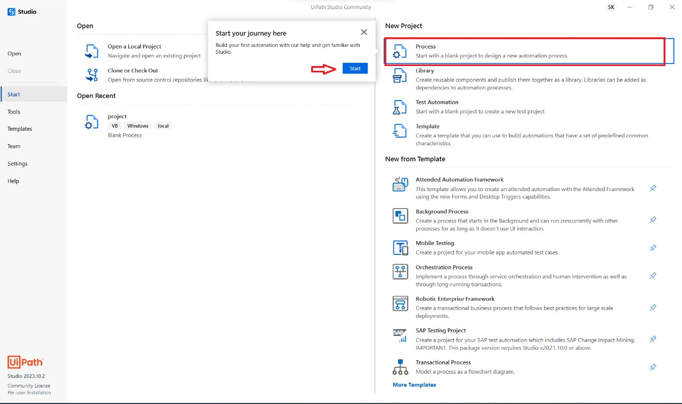

Step 2: The New Blank Process window is displayed

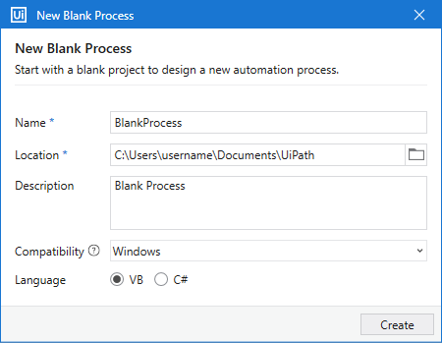

1. Enter a name for the new project and a description that summaries what you are aiming to do with this automation project.
2. Select the location where to create the project.
3. Click Create. The new project is opened in Studio.

Step 3: Install Packages

Open UiPath Studio and create a Transactional Process template, which is the best template for decision-based actions. Once the dependencies and workspace are created, click on Manage Packages on the Ribbon.

Now, click on All packages in the left pane and search for the package UiPath.word.Activities in the search box. Once it appears, click Install.

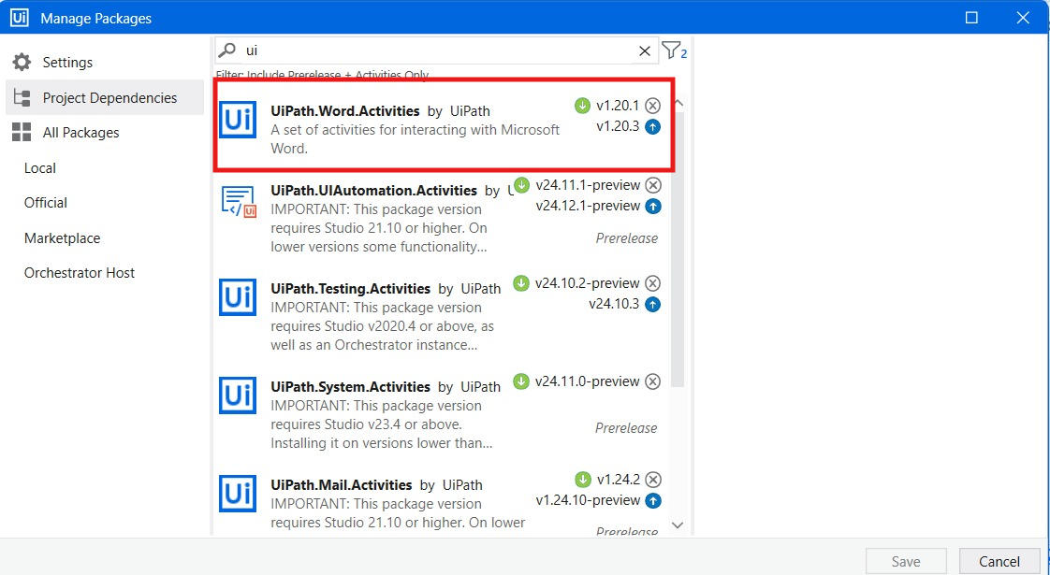

Step 4: Now, click on All packages in the left pane and search for the package “UiPath.Mail.Activities “ in the search box. Once it appears, click Install.

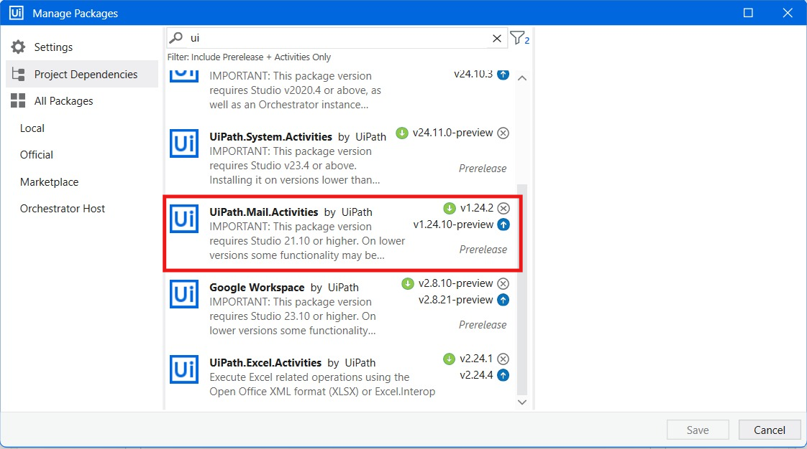

Step 5: Now, click on All packages in the left pane and search for the package “UiPath. Excel. Activities “in the search box. Once it appears, click Install.

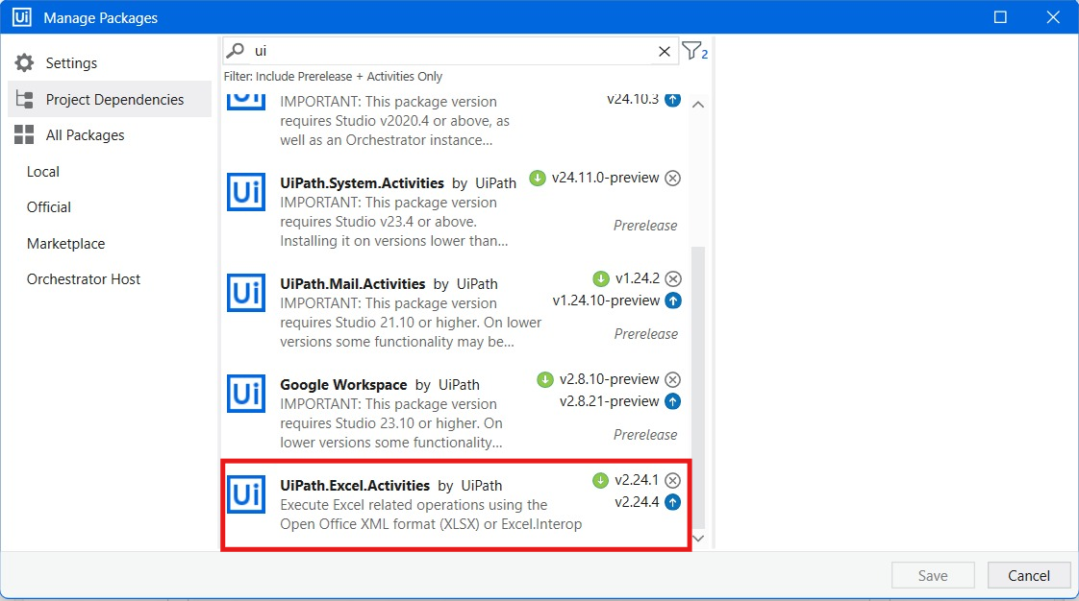

Step 6: Now, click on All packages in the left pane and search for the package “Google Workspace “in the search box. Once it appears, click Install.

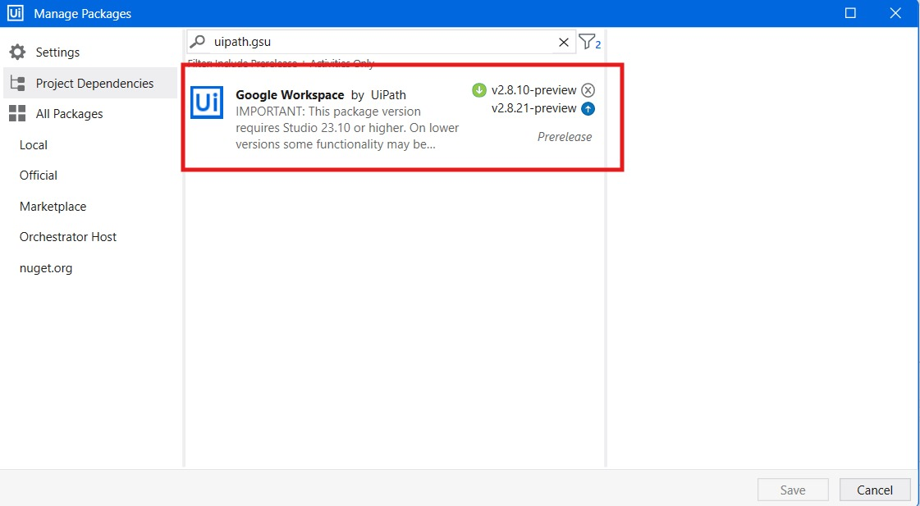

Step 7: The very first thing to do is drag and drop the “Excel Application Scope” in to the main sequence from the activities panel. And also add the location the Excel file location path stored in the device in the place of “Workbook path” (shown in the image7.2).

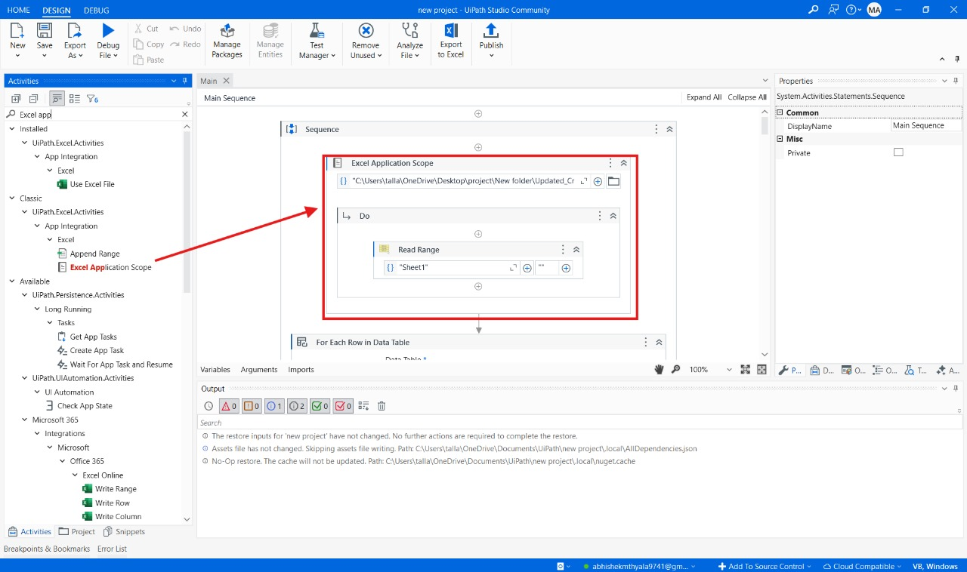

Image 7.1

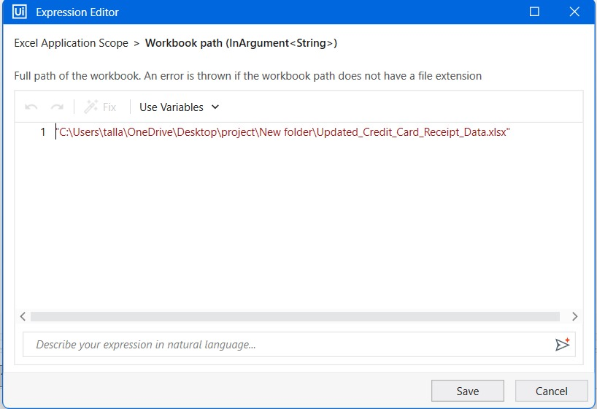

Image7.2

Step 8: Drag and drop the “Read Range Activity” in the place of “DO” in the “Excel Application Scope” and write your excel sheet name in the double quotes.

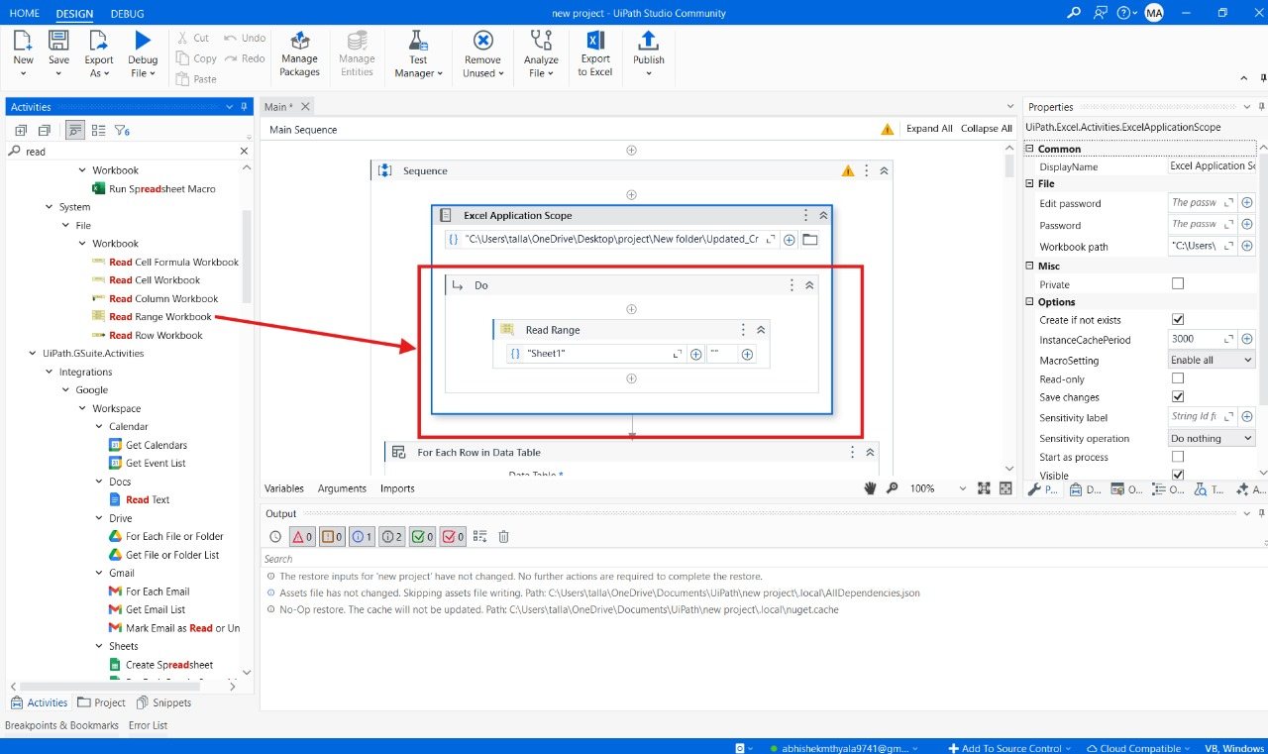

Step 9: Drag and drop the “For Each Row In Data Table” from the activity panel in to the main sequence.

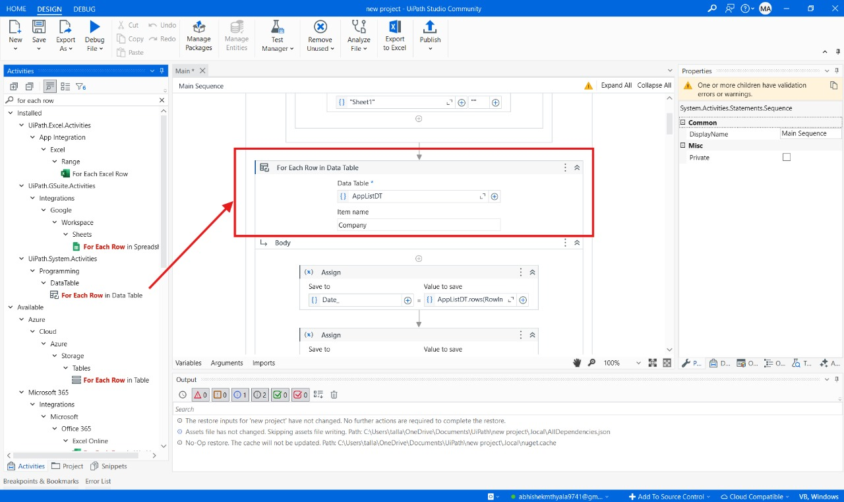

Step 10: Create a new variable in the place of Data Table as “AppListDT” and in properties panel locate the Index field. Click on the empty space in the Index field, press Ctrl + K, and create a new variable named RowIndex_APPListDT.

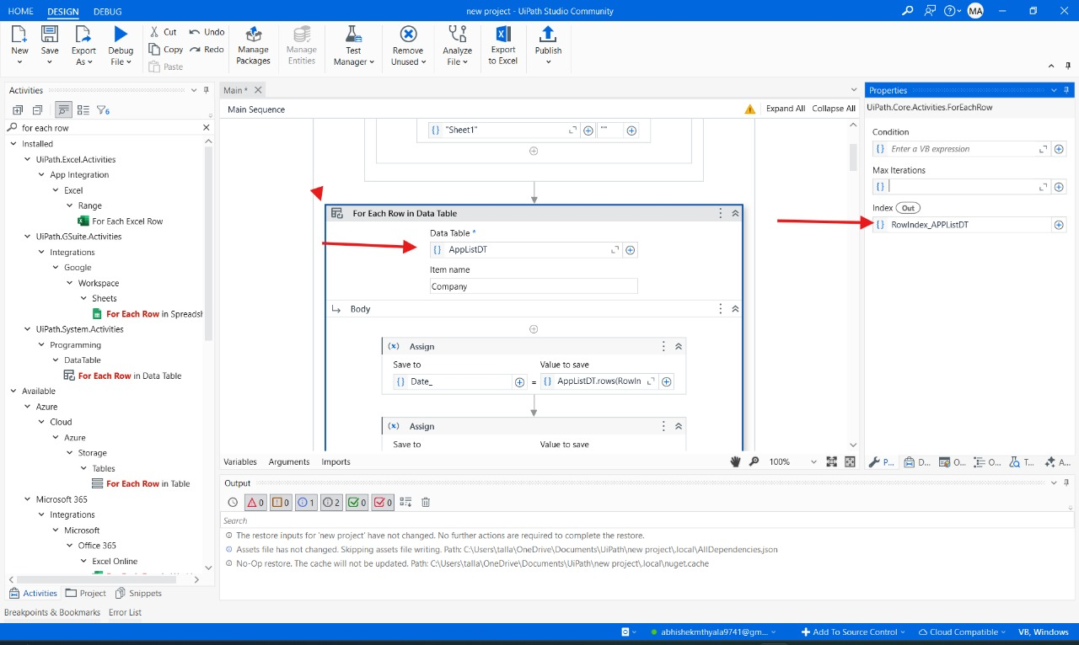

Step 11: Drag and drop the “Assign activity” from the activity panel and place in the body field of for Each row in the data table and in the field of save to create a variable called “Date_” and in the field of value to save write an expression “AppListDT.rows(RowIndex_AppListDT).item("Date").ToString”.

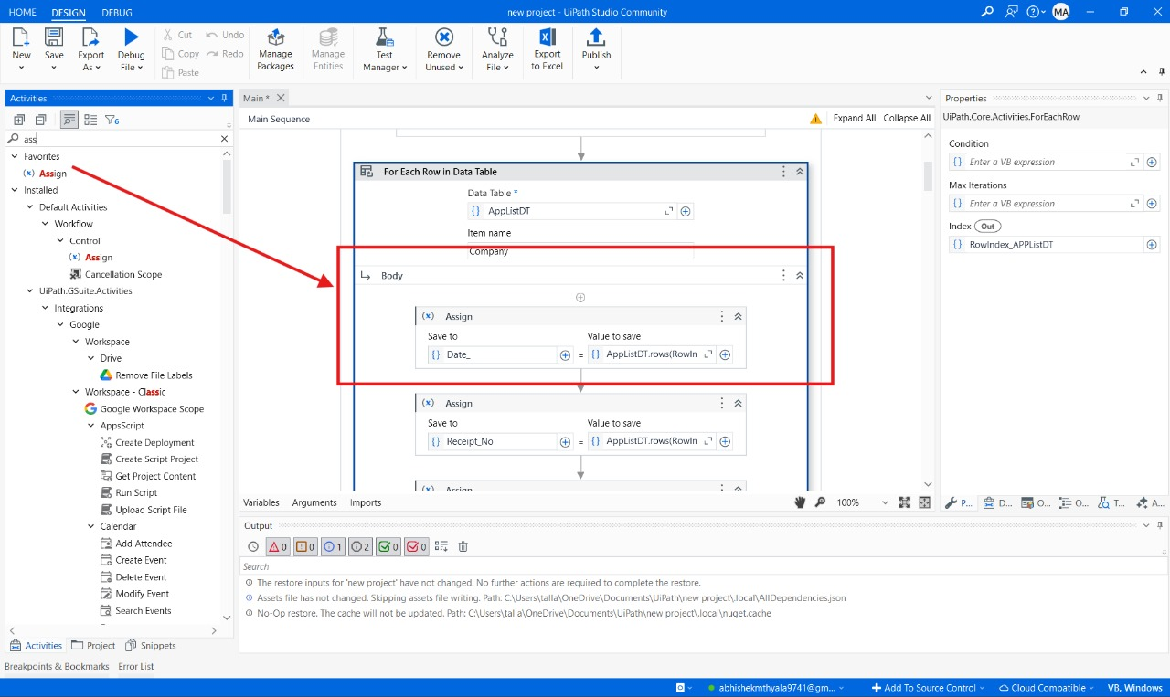

Step 12: Drag and drop the “Assign Activity” from the activity panel and place in the body field of for Each row in the data table and in the field of save to create a variable called “Receipt_No” and in the field of value to save write an expression “AppListDT.rows(RowIndex_AppListDT).item("Receipt No.").ToString”.

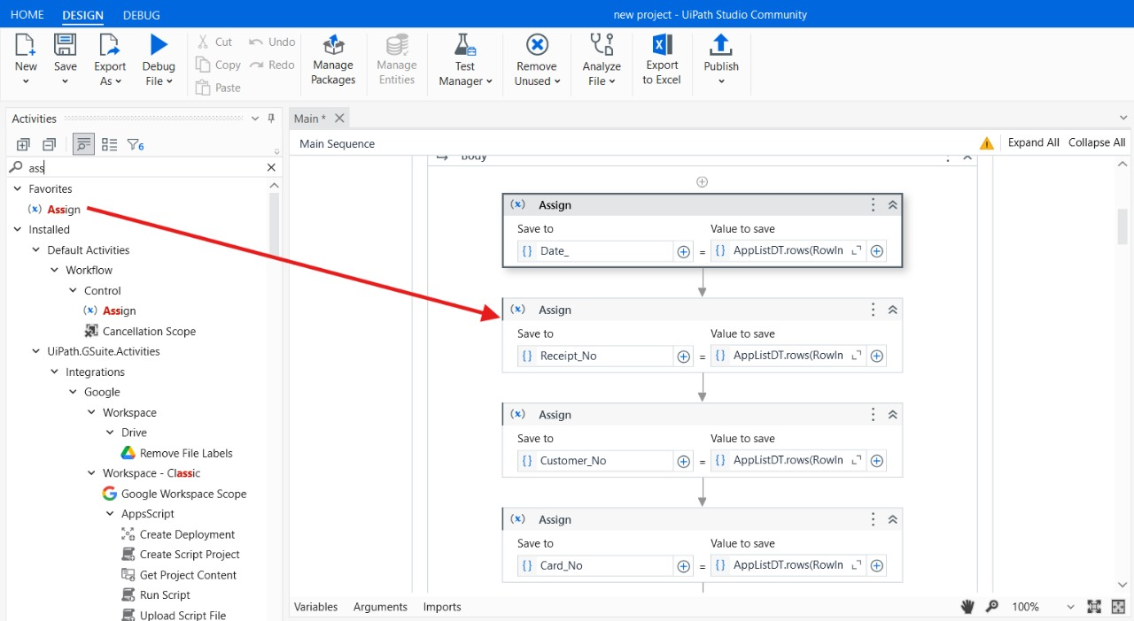

Step 13: Drag and drop the “Assign Activity” from the activity panel and place in the body field of for Each row in the data table and in the field of save to create a variable called “Customer_No” and in the field of value to save write an expression “AppListDT.rows(RowIndex_AppListDT).item("Customer No.").ToString”.

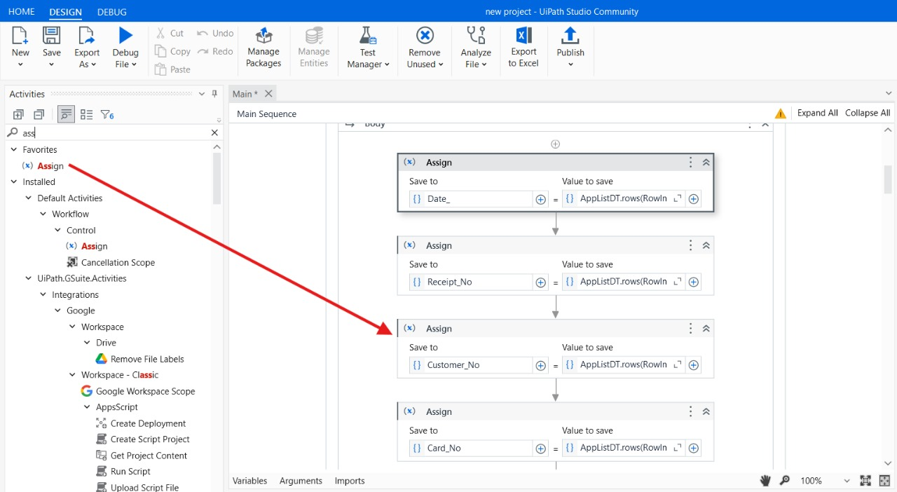

Step 14: Drag and drop the “Assign Activity” from the activity panel and place in the body field of for Each row in the data table and in the field of save to create a variable called “Card_No” and in the field of value to save write an expression “AppListDT.rows(RowIndex_AppListDT).item("Credit Card No.").ToString”.

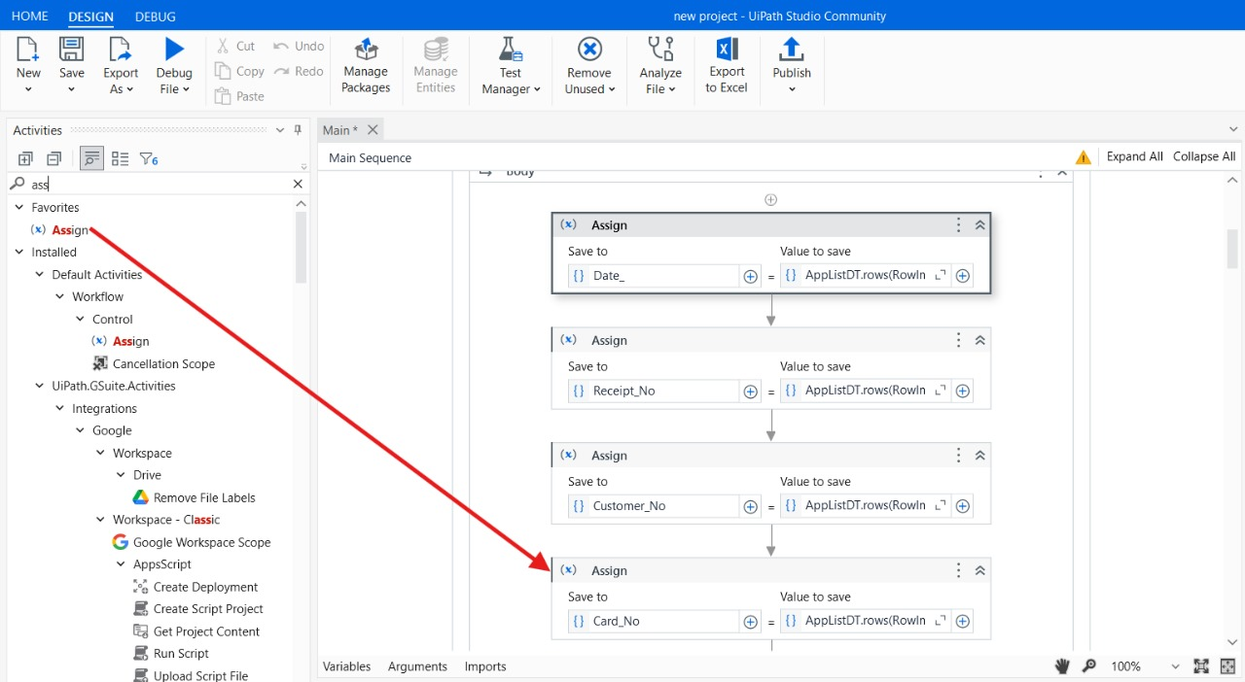

Step 15: Drag and drop the “Assign Activity” from the activity panel and place in the body field of for Each row in the data table and in the field of save to create a variable called “Transaction_Id” and in the field of value to save write an expression “AppListDT.rows(RowIndex_AppListDT).item("Transaction ID").ToString”.

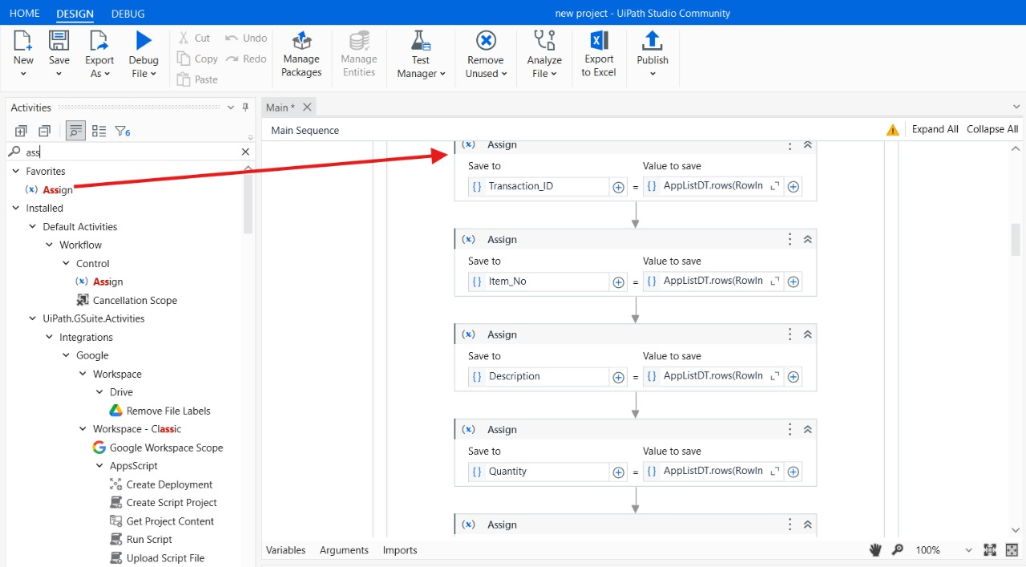

Step 16: Drag and drop the “Assign Activity” from the activity panel and place in the body field of for Each row in the data table and in the field of save to create a variable called “Item_No” and in the field of value to save write an expression “AppListDT.rows(RowIndex_AppListDT).item("Item No.").ToString”.

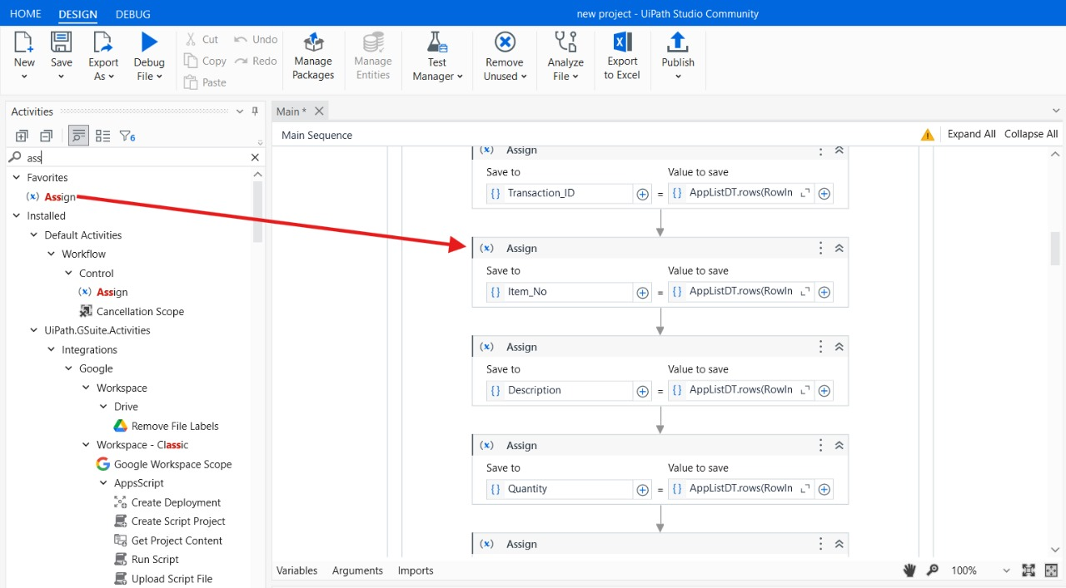

Step 17: Drag and drop the “Assign Activity” from the activity panel and place in the body field of for Each row in the data table and in the field of save to create a variable called “Description” and in the field of value to save write an expression “AppListDT.rows(RowIndex_AppListDT).item("Description").ToString”.

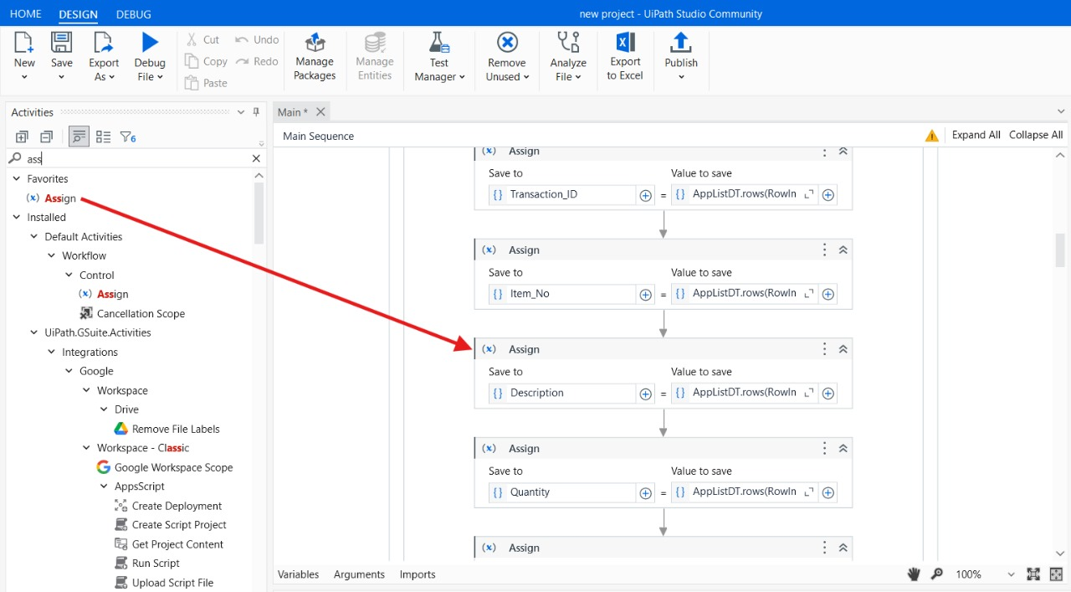

Step 18: Drag and drop the “Assign Activity” from the activity panel and place in the body field of for Each row in the data table and in the field of save to create a variable called “Quantity” and in the field of value to save write an expression “AppListDT.rows(RowIndex_AppListDT).item("Quantity").ToString”.

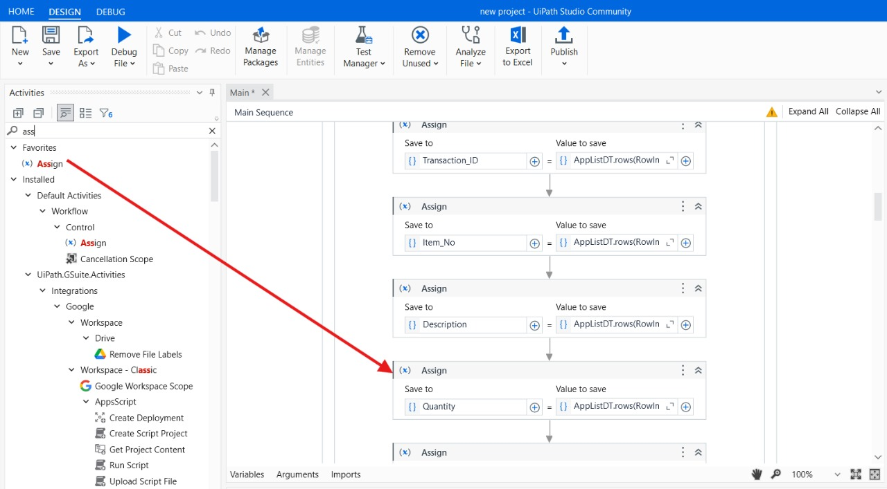

Step 19: Drag and drop the “Assign Activity” from the activity panel and place in the body field of for Each row in the data table and in the field of save to create a variable called “Unit_Price” and in the field of value to save write an expression “AppListDT.rows(RowIndex_AppListDT).item("Unit Price").ToString”.

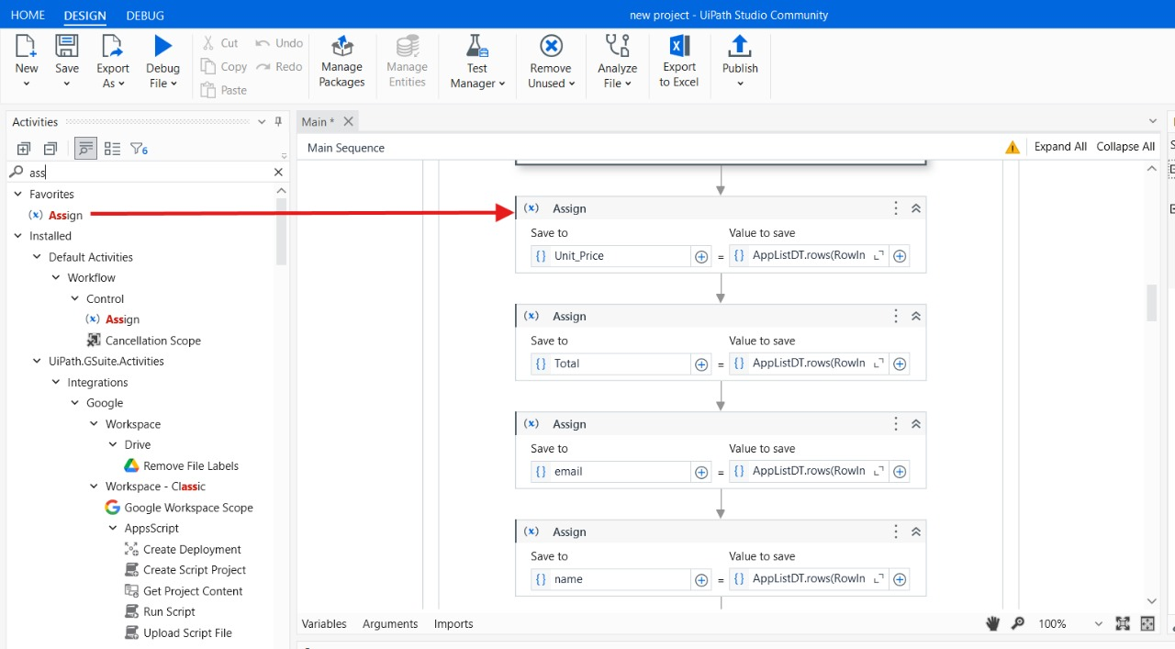

Step 20: Drag and drop the “Assign Activity” from the activity panel and place in the body field of for Each row in the data table and in the field of save to create a variable called “Total” and in the field of value to save write an expression “AppListDT.rows(RowIndex_AppListDT).item("Total").ToString”.

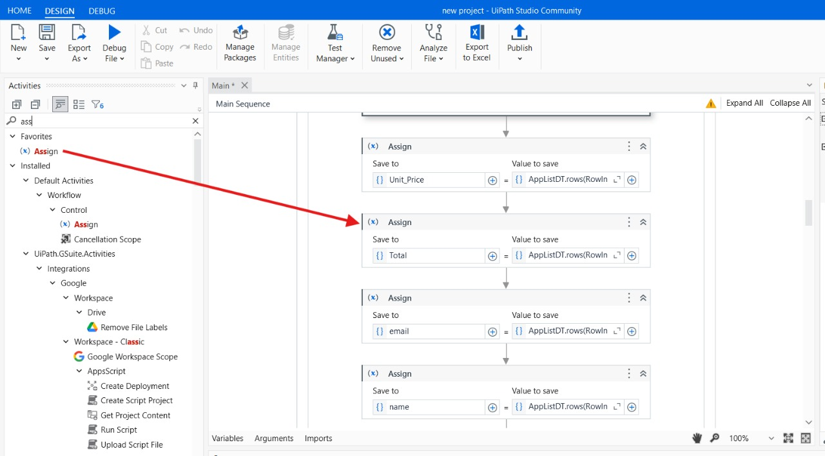

Step 21: Drag and drop the “Assign Activity” from the activity panel and place in the body field of for Each row in the data table and in the field of save to create a variable called “Email” and in the field of value to save write an expression “AppListDT.rows(RowIndex_AppListDT).item("Email").ToString”.

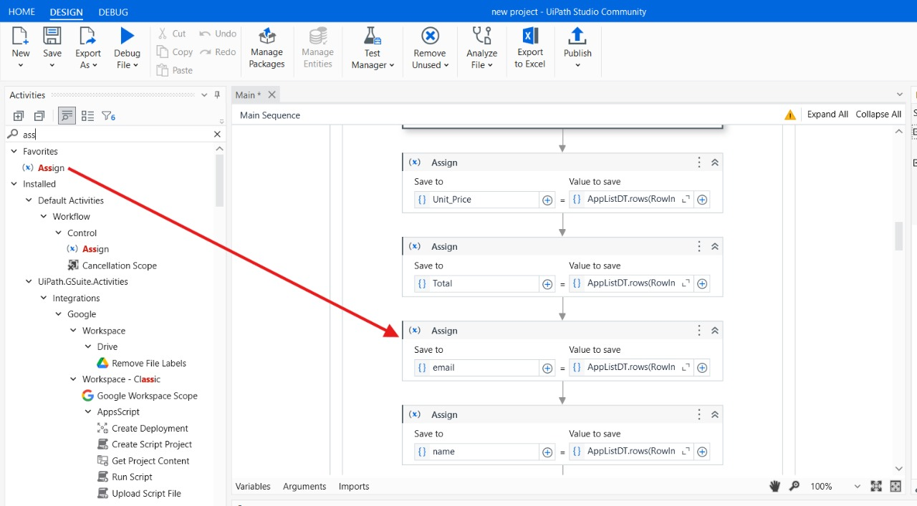

Step 22: Drag and drop the “Assign Activity” from the activity panel and place in the body field of for Each row in the data table and in the field of save to create a variable called “Name” and in the field of value to save write an expression “AppListDT.rows(RowIndex_AppListDT).item("Name").ToString”.

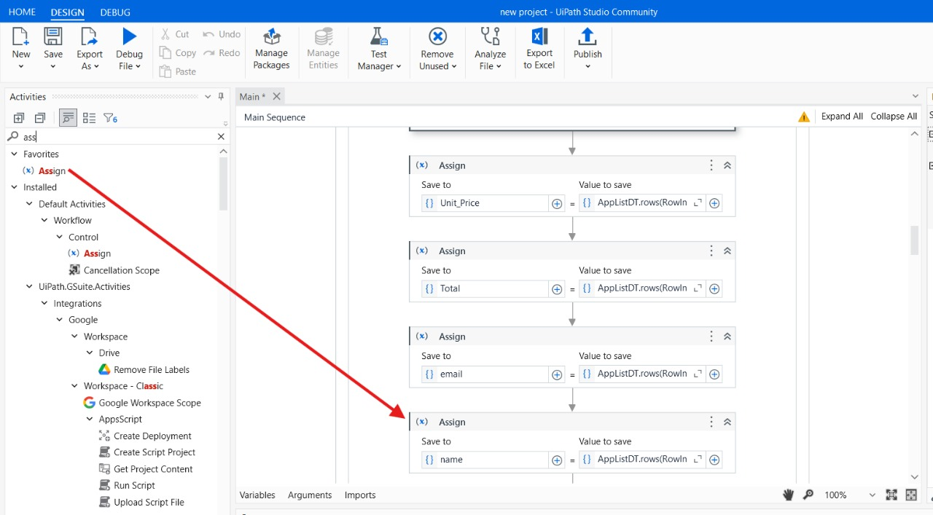

Step 23: Drag and drop the “Word Application Scope” in field of document path enter your Template Location Path.

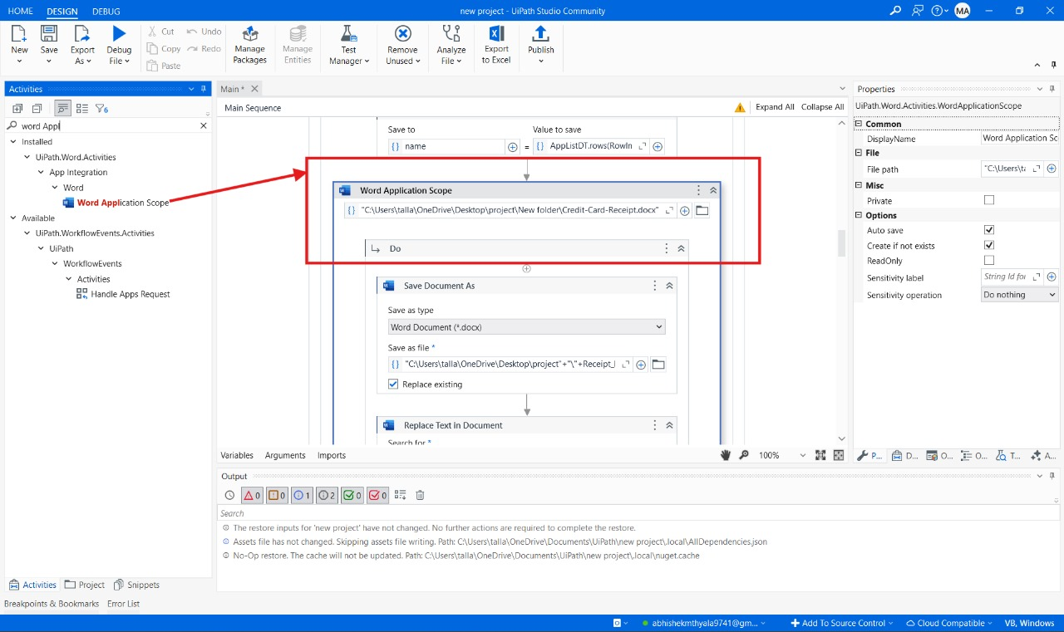

Step 24: Drag and drop the “Save Document As Activity” from the activity panel and place in the DO filed of “Word Application Scope”.In save document as activity find save as file field and enter the location path where the files should be saved.

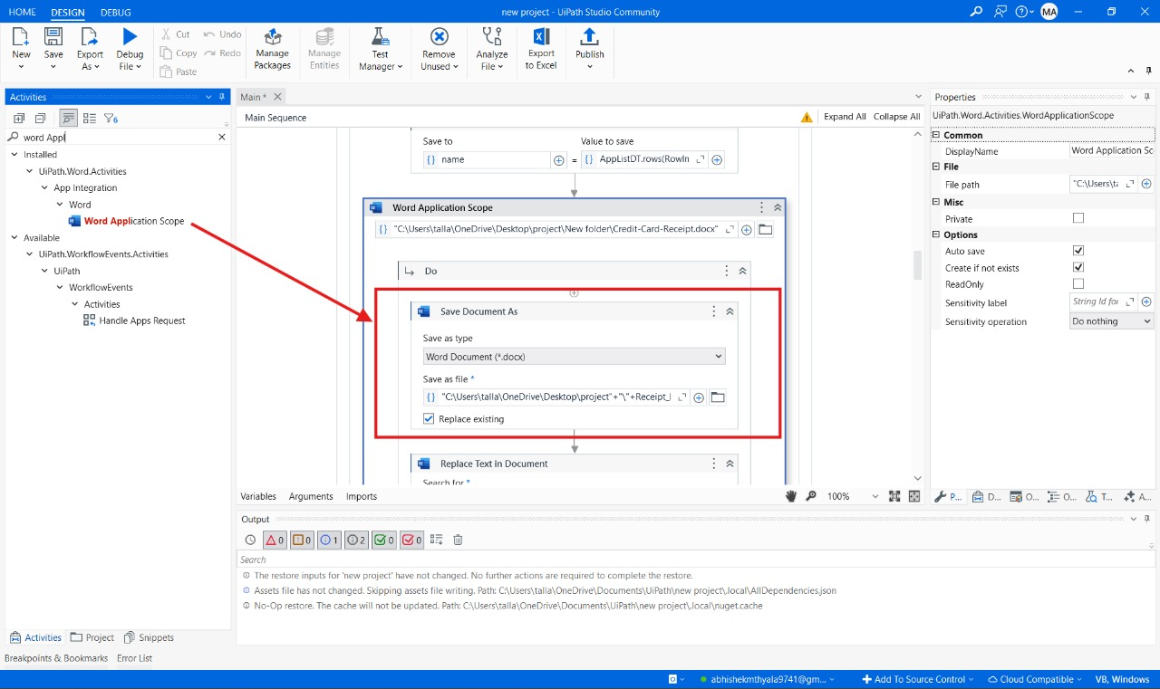

Step 25: Drag and drop the “Replace Text In Document Activity” from the activity panel and place in the DO filed of “Word Application Scope”. In Replace Text In Document Activity find search for filed and enter “Date_ex”. And in the place of replace with filed enter the variable “Date_”.

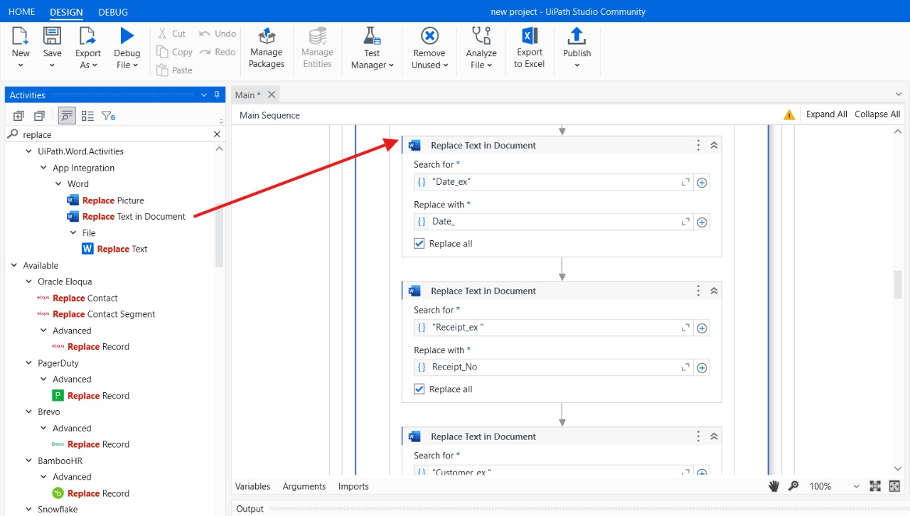

Step 26: Drag and drop the “Replace Text In Document Activity” from the activity panel and place in the DO filed of “Word Application Scope”. In Replace Text In Document Activity find search for filed and enter “Receipt_ex”. And in the place of replace with filed enter the variable “Receipt_No”.

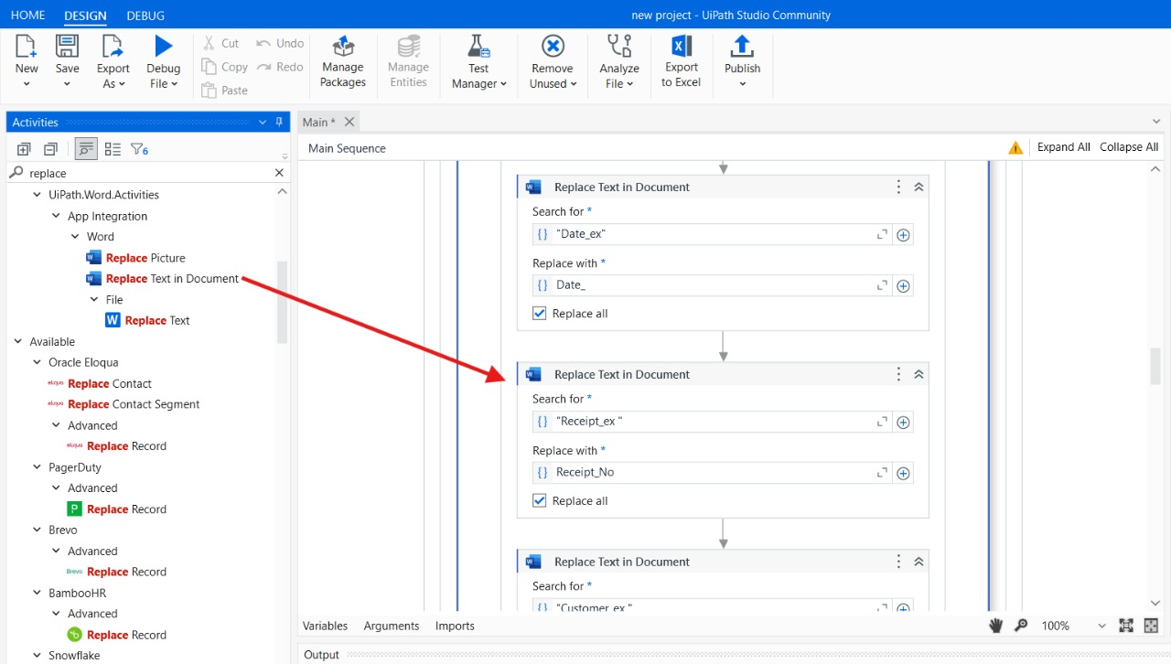

Step 27: Drag and drop the “Replace Text In Document Activity” from the activity panel and place in the DO filed of “Word Application Scope”. In Replace Text In Document Activity find search for filed and enter “Customer_ex”. And in the place of replace with filed enter the variable “Customer_No”.

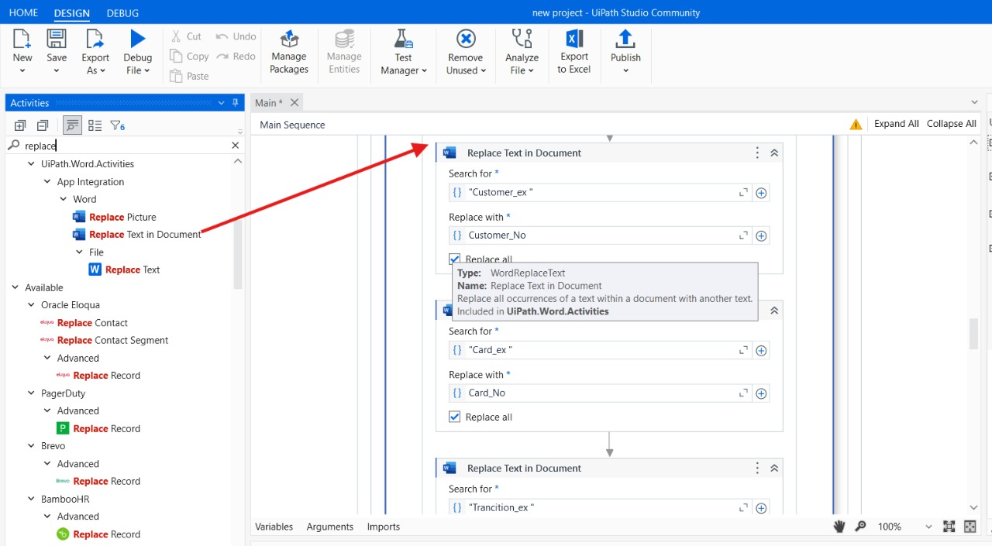

Step 28: Drag and drop the “Replace Text In Document Activity” from the activity panel and place in the DO filed of “Word Application Scope”. In Replace Text In Document Activity find search for filed and enter “Card_ex”. And in the place of replace with filed enter the variable “Card_No”.

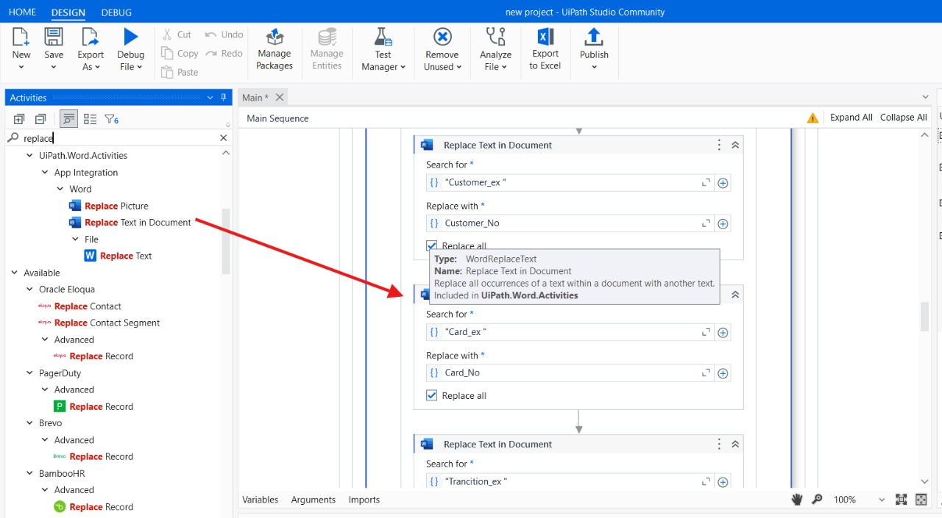

Step 29: Drag and drop the “Replace Text In Document Activity” from the activity panel and place in the DO filed of “Word Application Scope”. In Replace Text In Document Activity find search for filed and enter “Transation_ex”. And in the place of replace with filed enter the variable “Transation_Id”.

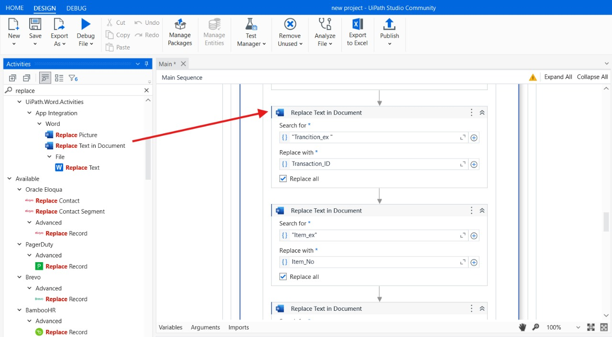

Step 30: Drag and drop the “Replace Text In Document Activity” from the activity panel and place in the DO filed of “Word Application Scope”. In Replace Text In Document Activity find search for filed and enter “Item_ex”. And in the place of replace with filed enter the variable “Item_No”.

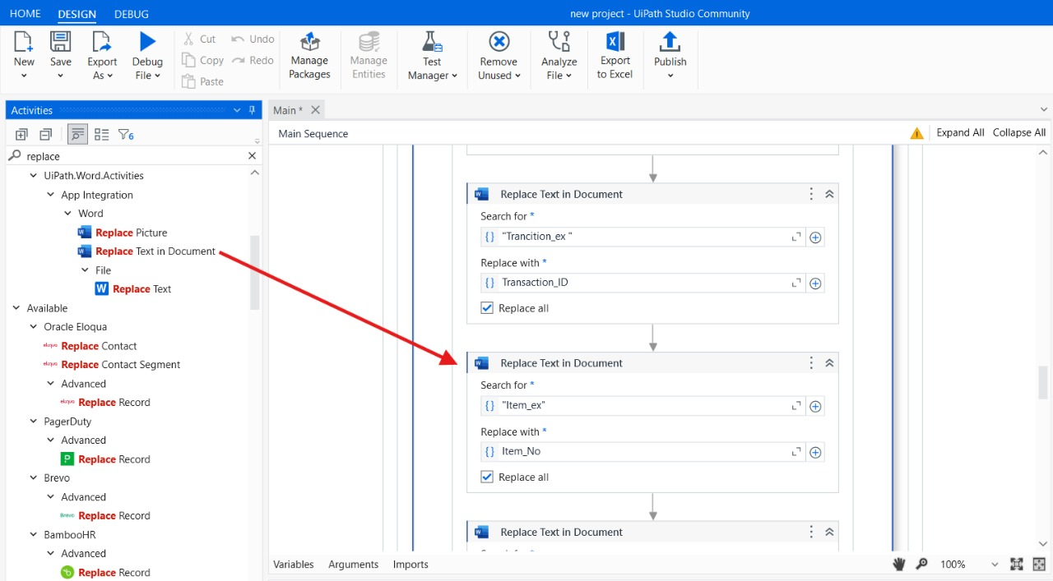

Step 31: Drag and drop the “Replace Text In Document Activity” from the activity panel and place in the DO filed of “Word Application Scope”. In Replace Text In Document Activity find search for filed and enter “Description_ex”. And in the place of replace with filed enter the variable “Description”.

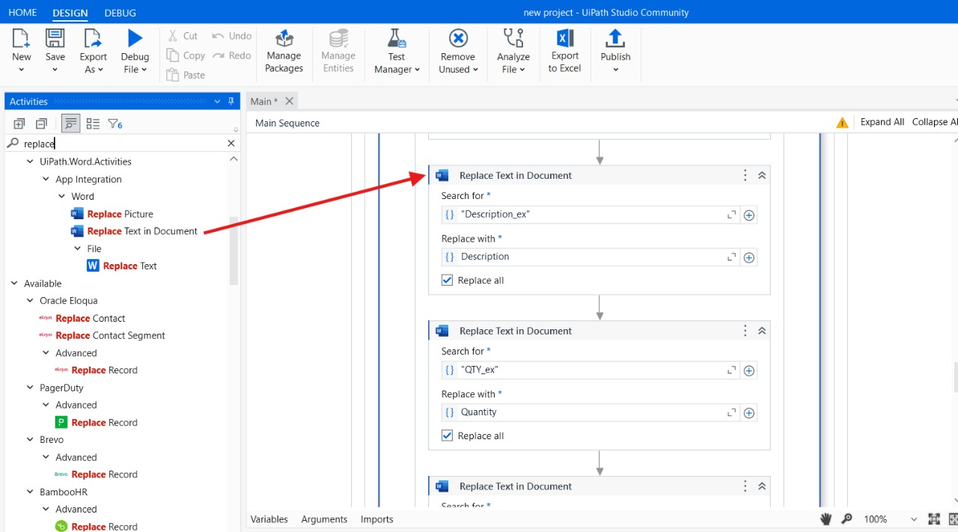

Step 32: Drag and drop the “Replace Text In Document Activity” from the activity panel and place in the DO filed of “Word Application Scope”. In Replace Text In Document Activity find search for filed and enter “QTY_ex”. And in the place of replace with filed enter the variable “Quantity”.

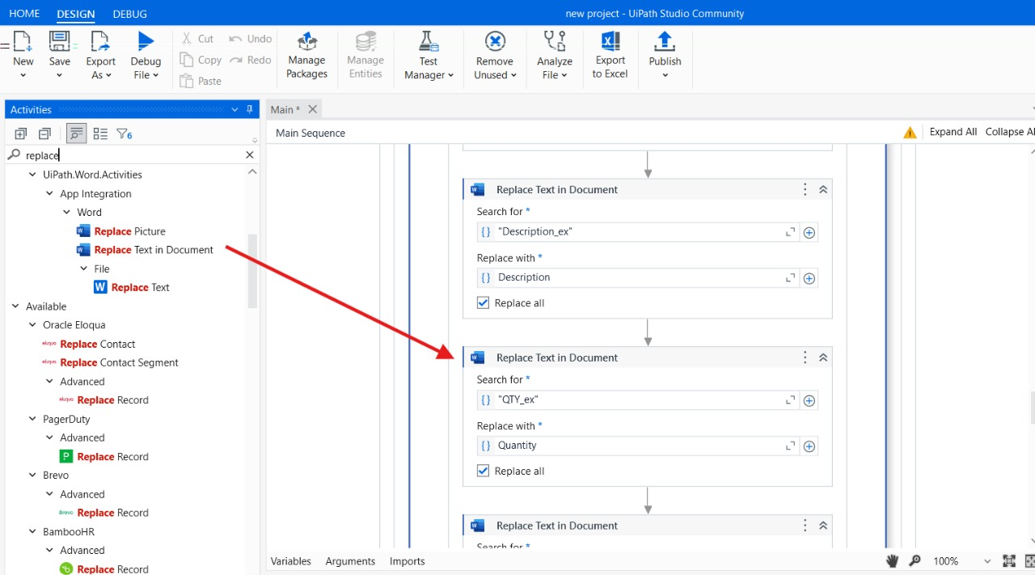

Step 33: Drag and drop the “Replace Text In Document Activity” from the activity panel and place in the DO filed of “Word Application Scope”. In Replace Text In Document Activity find search for filed and enter “Unit_ex”. And in the place of replace with filed enter the variable “Unit_Price”.

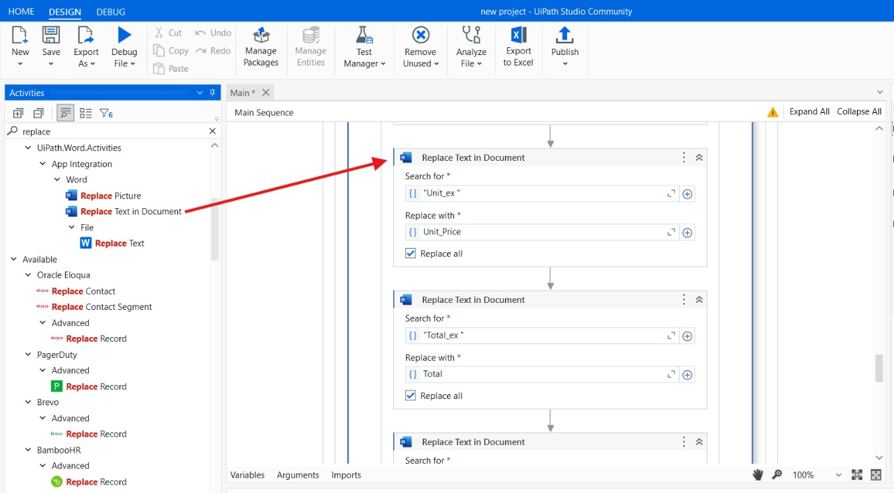

Step 34: Drag and drop the “Replace Text In Document Activity” from the activity panel and place in the DO filed of “Word Application Scope”. In Replace Text In Document Activity find search for filed and enter “Total_ex”. And in the place of replace with filed enter the variable “Total”.

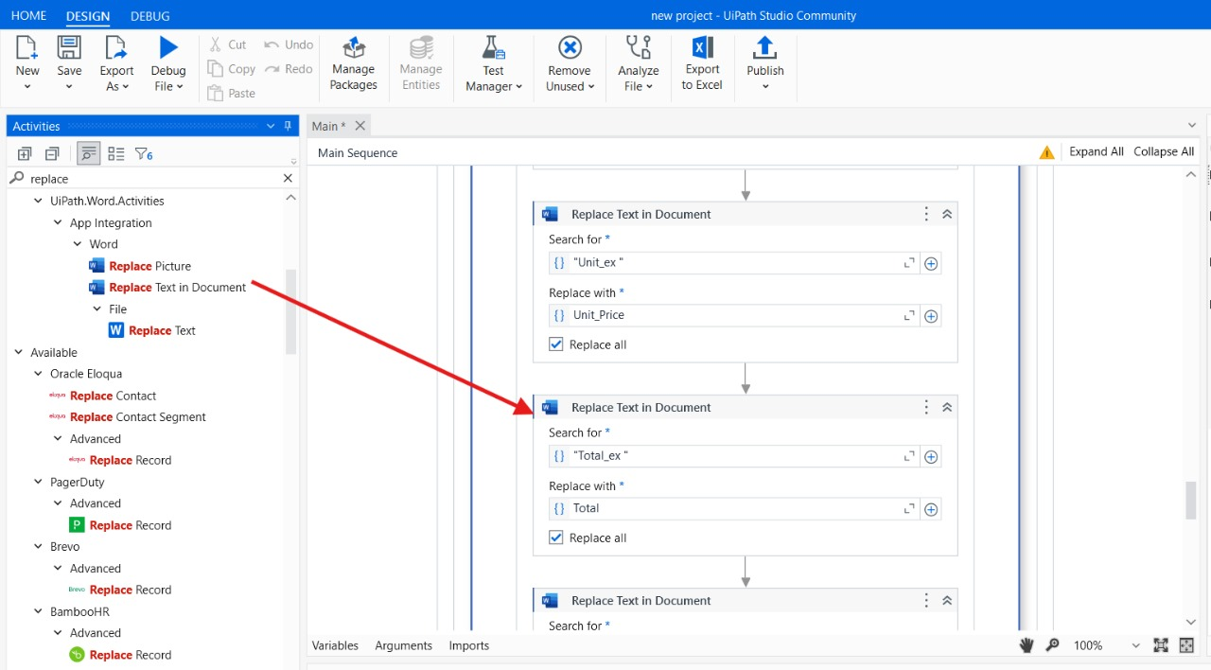

Step 35: Drag and drop the “Save Document As Activity” from the activity panel and place in the DO filed of “Word Application Scope”.In save document as activity find save as file field and enter the location path where the files should be saved.

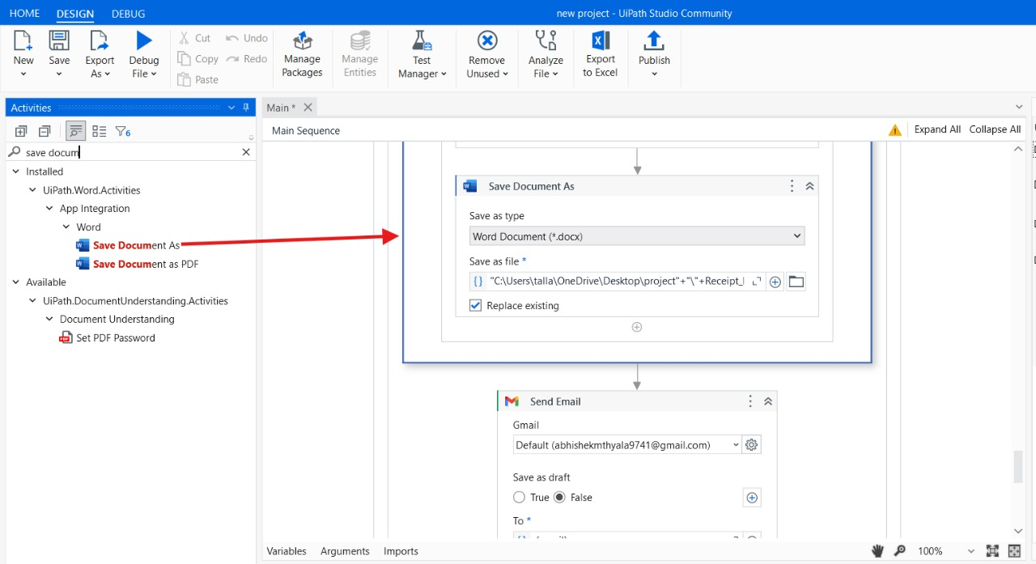

Step 36: Drag and drop the “Send Email Activity” from the activity panel and in the gmail filed connect to your gmail in “To” filed enter a variable “{email}” and enter your subject and body in the attachments filed locate your saved file location path you did in the step no:35. 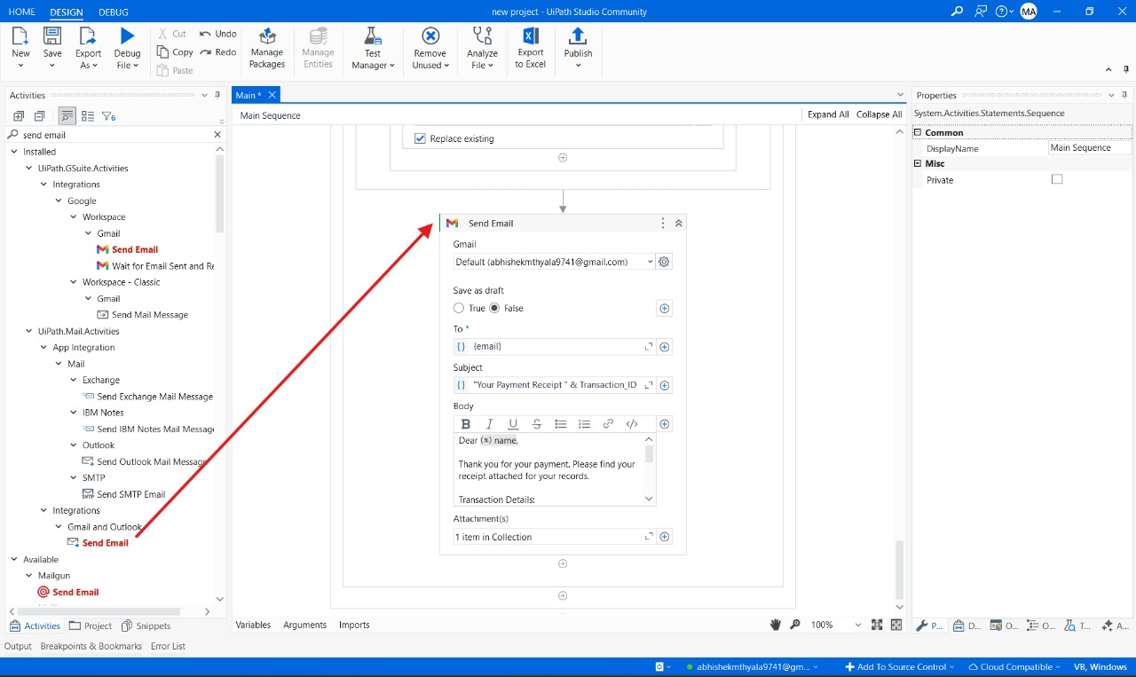

**CHAPTER-7**

**TIMELINE FOR EXECUTION OF PROJECT**

**(GANTT CHART)**

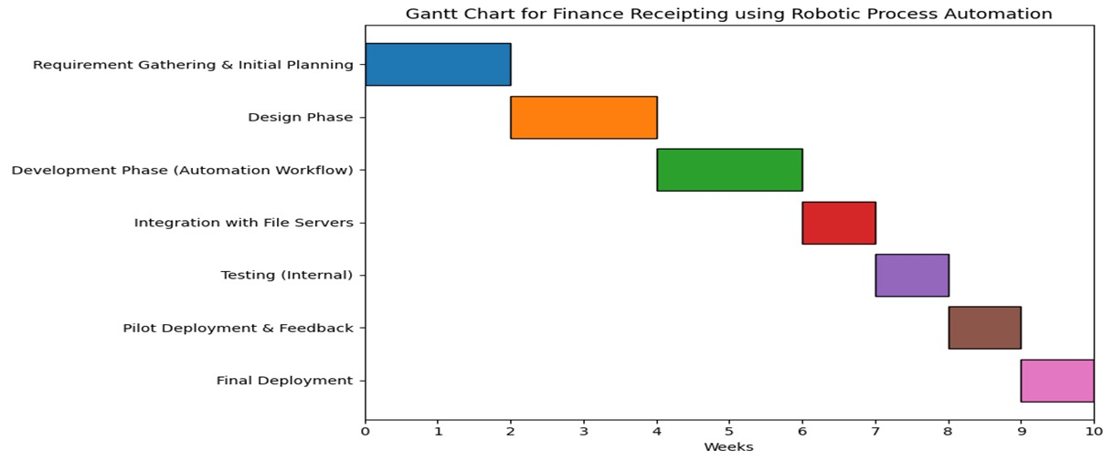

**CHAPTER-8**

**OUTCOMES**

The implementation of an automated finance receipting system using UiPath brings significant improvements in operational efficiency. Automating tasks such as data extraction, receipt generation, and email dispatch drastically reduces the time required to process transactions, enabling businesses to handle large volumes quickly and efficiently. This streamlined workflow eliminates bottlenecks and ensures consistent performance, even during peak transaction periods.

By eliminating manual data entry and template population, the system ensures improved accuracy, significantly reducing errors in financial receipts. This accuracy not only maintains the integrity of financial records but also builds customer trust by delivering error-free documentation. Additionally, automated file management ensures that receipts are systematically saved and easily retrievable, improving record-keeping and audit readiness.

Scalability is another key outcome of the system. As businesses grow and transaction volumes increase, the automated solution can seamlessly handle the additional workload without requiring additional resources or manual intervention. This makes the system future-proof and capable of supporting long-term business growth.

Cost savings are achieved by reducing reliance on manual processes, lowering labor costs, and minimizing expenses related to correcting errors or managing delays. Furthermore, the automation of email dispatch ensures that customers receive their receipts promptly, enhancing satisfaction and communication with clients.

The system incorporates robust error-handling and logging mechanisms, ensuring smooth operations even when issues like missing data or invalid email addresses arise. These features allow for quick identification and resolution of errors without disrupting the overall workflow.

Lastly, the system ensures secure handling of sensitive customer information, adhering to data protection regulations such as GDPR or PCI-DSS. This reduces the risk of data breaches and ensures compliance, safeguarding the business’s reputation and customer trust.

**CHAPTER-9**

**RESULTS AND DISCUSSIONS**

The implementation of RPA in finance receipting is expected to produce several positive outcomes. First, the automation of data extraction and receipt generation will significantly reduce the time required to process transactions, leading to faster turnaround times and improved efficiency. Second, by eliminating manual data entry, the system will improve accuracy, reducing the risk of errors in receipts and financial records. Third, the automation of email distribution ensures that customers receive their receipts promptly, improving customer satisfaction. Additionally, the system will be scalable, allowing businesses to handle increasing transaction volumes without additional resources. Finally, the project will ensure that customer data is handled securely, in compliance with data protection regulations.

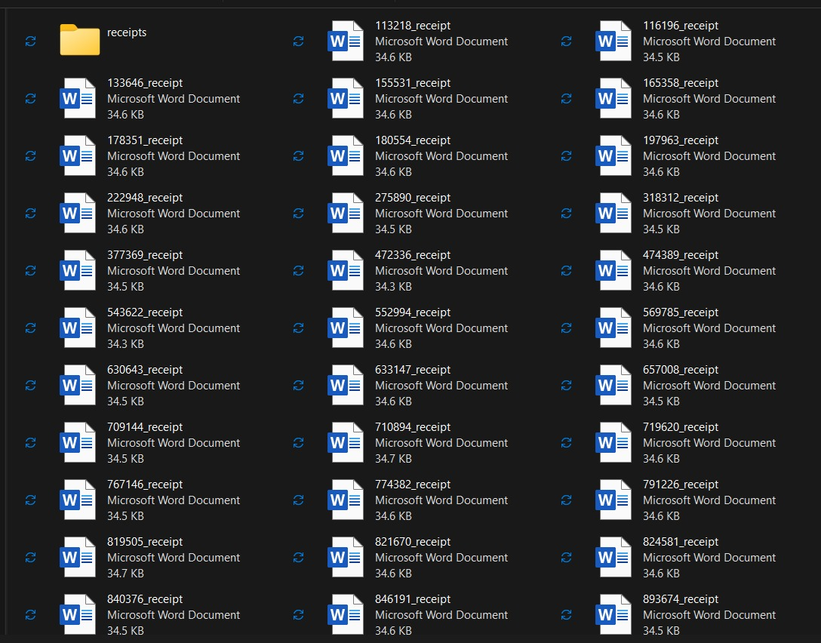

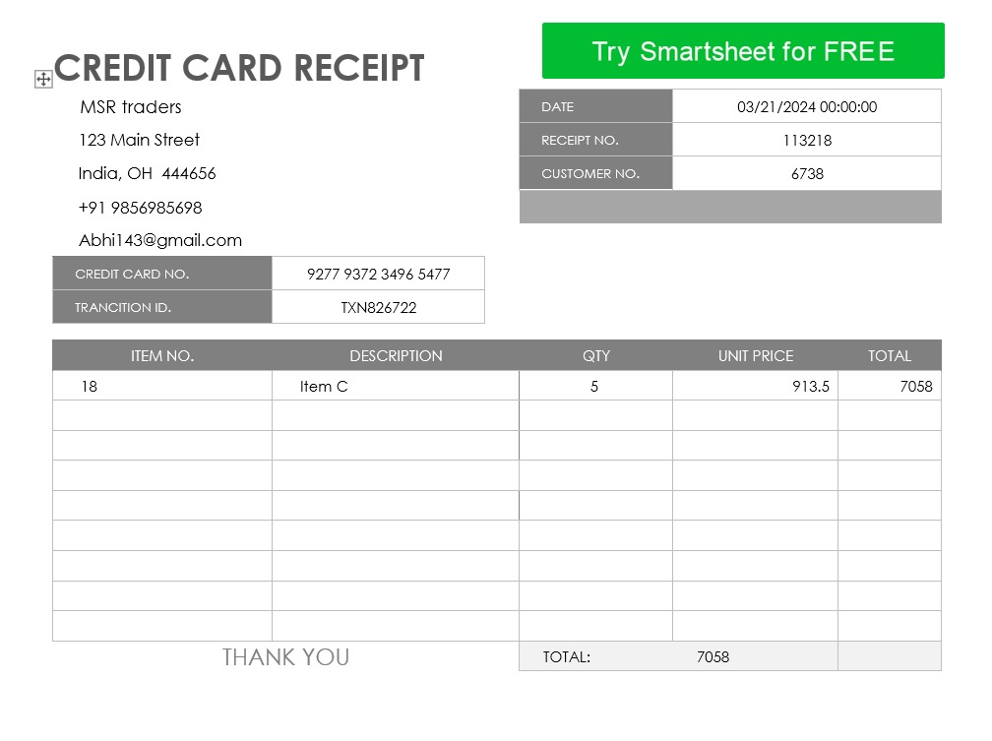

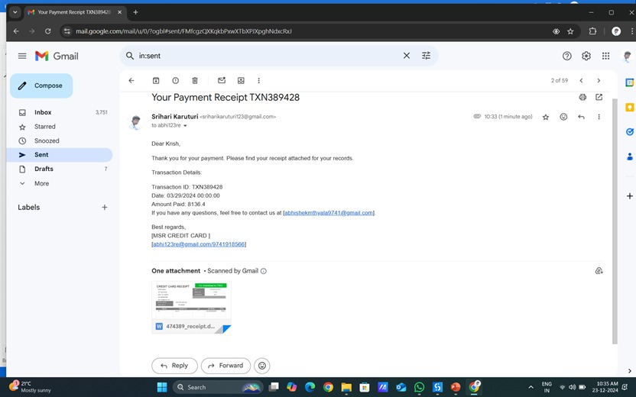

**CHAPTER-10**

**CONCLUSION**

The implementation of an automated finance receipting system using UiPath marks a significant advancement in addressing the inefficiencies and challenges of traditional manual processes. By automating tasks such as data extraction, receipt generation, file management, and email dispatch, the system streamlines workflows, reduces processing time, and minimizes errors. This ensures consistent, accurate, and timely receipting, which is critical for businesses handling large transaction volumes.

Moreover, the system’s scalability, adaptability, and robust error-handling mechanisms make it a future-proof solution capable of evolving with business needs. Enhanced data security and compliance with regulations also ensure the safe handling of sensitive customer information, fostering trust and reliability. By eliminating repetitive tasks, this project not only reduces operational costs but also allows businesses to focus on strategic initiatives, improving overall productivity.

In conclusion, this project demonstrates the transformative potential of RPA in financial operations, offering a practical, efficient, and scalable solution for finance receipting. It sets a strong foundation for businesses seeking to embrace automation and optimize their back-office processes for sustained success and customer satisfaction.

**REFERENCES**

[1] Chan, S.W.S., Ip, S., Wan, C.F.C., Yiu, H.F.D. (2021). How would the emerging technology affect the future of auditing? Outstanding Academic Papers by Students (OAPS), City University of Hong Kong. <http://dspace.cityu.edu.hk/handle/2031/9133>.

[2] Cohen, M., Rozario, A.M., Zhang, C.A. (2019). Exploring the Use of Robotic Process Automation (RPA) in Substantive Audit Procedures: A Case Study. CPA Journal, July.

[3] Issac, R., Muni, R., & Desai, K. (2018). Delineated Analysis of Robotic Process Automation Tools. 2018 Second International Conference on Advances in Electronics, Computers and Communications (ICAECC), Bangalore, pp. 1-5. doi: 10.1109/ICAECC.2018.8479511.

[4] KPMG (2020). RPA in Internal Audit: Emerging Trends and Applications. <https://home.kpmg/xx/en/home/insights/2020/06/rpa-internal-audit.html>.

[5] Deloitte (2019). Robotic Process Automation for Audit: A Game Changer for the Future of Auditing. [https://www2.deloitte.com/insights/us/en/topics/digital-transformation/robotic-process-automation-audit.html.](https://www2.deloitte.com/insights/us/en/topics/digital-transformation/robotic-process-automation-audit.html.%20)

[6] Rozario, A. M., & Vasarhelyi, M. A. (2018). How RPA is Transforming the Auditing Process. Journal of Emerging Technologies in Accounting, 15(2), 37–46.

[7] PWC (2017). The Impact of Automation on Auditing: Moving Forward with RPA. <https://www.pwc.com/gx/en/services/assurance/the-impact-of-automation-on-audit.html>.

[8] Lacity, M. C., & Willcocks, L. P. (2018). Robotic Process Automation and Risk Mitigation in Auditing. Journal of Information Technology, 33(2), 81-98.

<https://www.uipath.com/resources/automation-case-studies>.

[10] Deloitte (2023). Delivering Breakthrough Outcomes Through Intelligent Automation. This publication discusses how intelligent automation drives business efficiency and innovation. Retrieved from <https://www2.deloitte.com/us/en.html>.

[11] Ernst & Young (2022). The Role of RPA in Financial Receipting Workflows. This report highlights the benefits of RPA in streamlining receipting processes. Retrieved from <https://www.ey.com/en_gl>.

[12] Forrester (2022). Scaling Financial Automation with RPA: Challenges and Opportunities. This research identifies challenges and strategies for scaling RPA in financial operations. Accessed at <https://go.forrester.com/research/>.

[13] Accenture (2022). The Future of Financial Automation. This article provides insights into the evolving landscape of financial automation. Retrieved from <https://www.accenture.com/us-en>.

[14] PWC (2023). Strategic RPA Adoption in Financial Services. This study focuses on strategies for integrating RPA into financial workflows effectively. Retrieved from <https://www.pwc.com/gx/en/services/assurance.html>.

[15] McKinsey & Company (2023). Digital Transformation and RPA. This report examines how digital transformation leverages RPA to optimize operations. Accessed at <https://www.mckinsey.com/>.

[16] Gartner (2022). RPA Trends in Financial Processes. This publication highlights emerging trends and innovations in RPA for financial services. Retrieved from <https://www.gartner.com/en>.

[17] UiPath Blog (2023). RPA Best Practices in Finance. This blog discusses key practices to maximize the benefits of RPA in financial processes. Retrieved from <https://www.uipath.com/blog>.

[18] IBM (2023). Implementing RPA in Financial Workflows. This guide outlines best practices for deploying RPA in finance. Retrieved from <https://www.ibm.com/cloud>.

[19] Capgemini (2022). RPA in Banking and Finance. This report discusses the integration of RPA in banking to enhance efficiency and compliance. Accessed at [https://www.capgemini.com](https://www.capgemini.com/).

[20] Harvard Business Review (2022). Automation in Finance: Balancing Efficiency and Security. This article explores how financial automation balances operational efficiency with security. Retrieved from <https://hbr.org/>

**APPENDIX-A**

**ENCLOSURES**

**1.Journal publication Paper Presented Certificates of all students.**

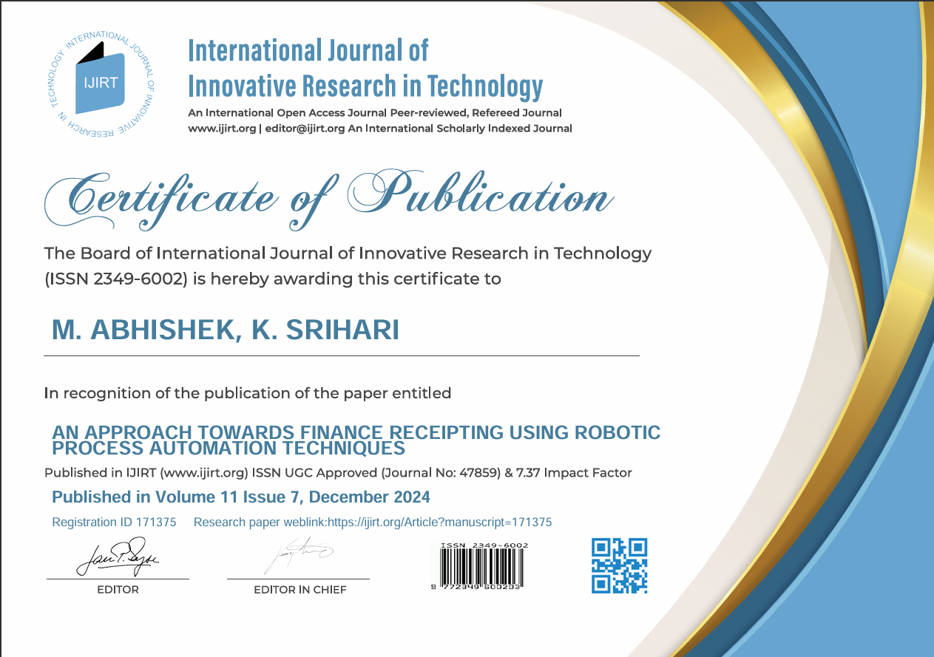

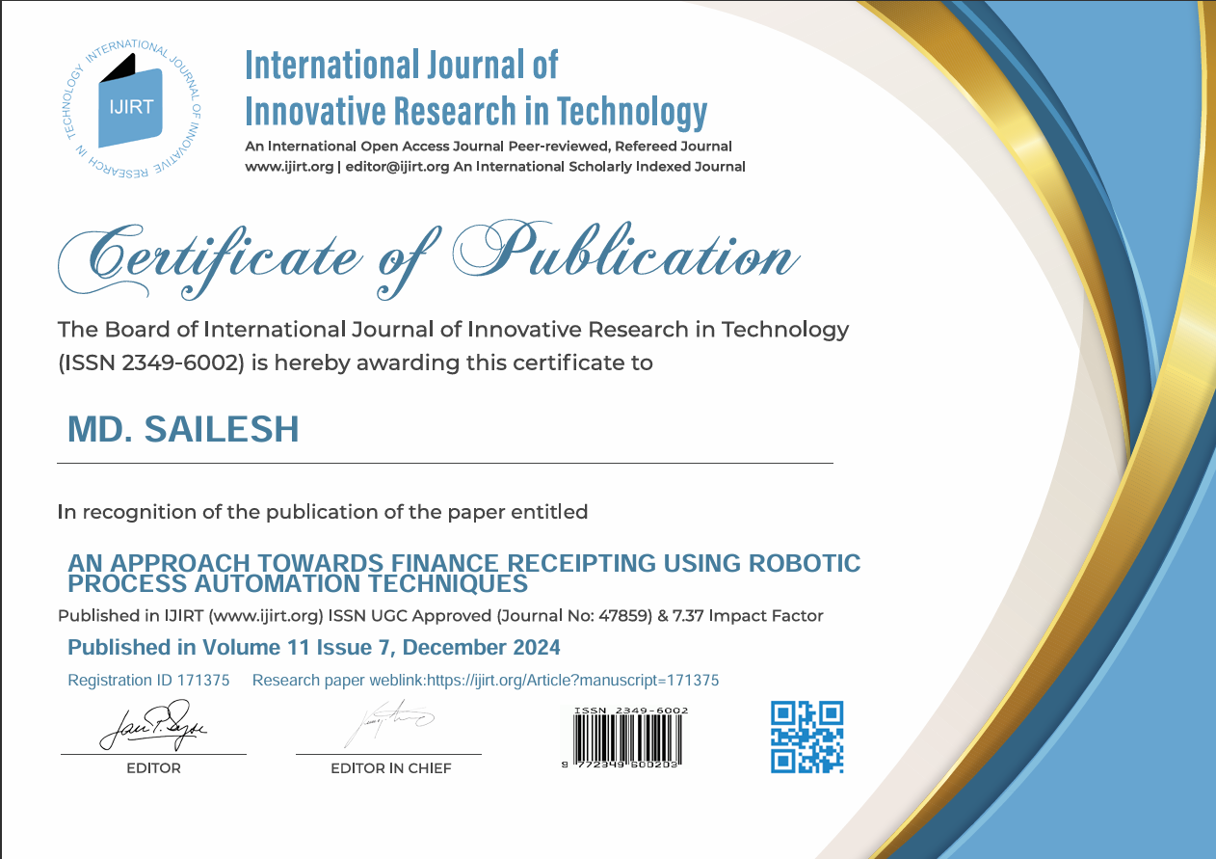

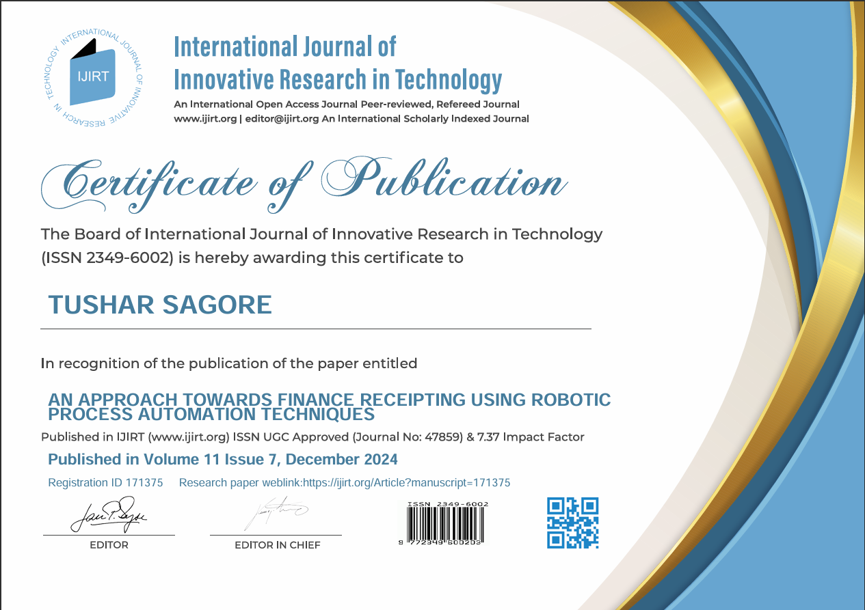

**2.Similarity Index / Plagiarism Check report clearly showing the Percentage (%).**



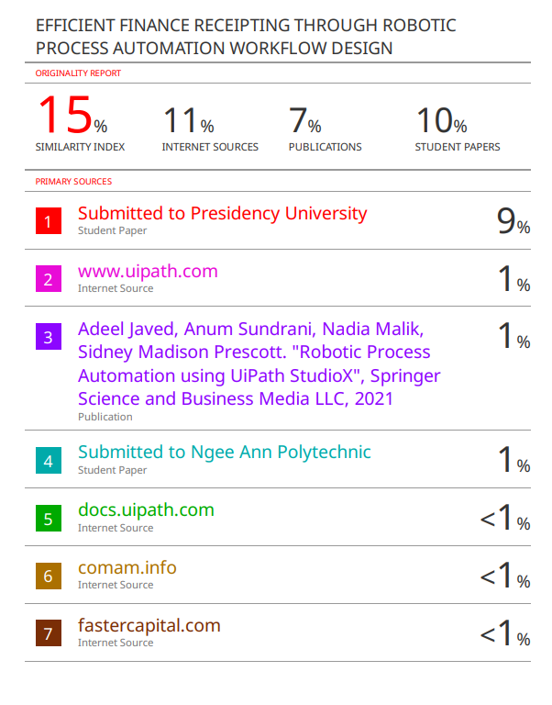

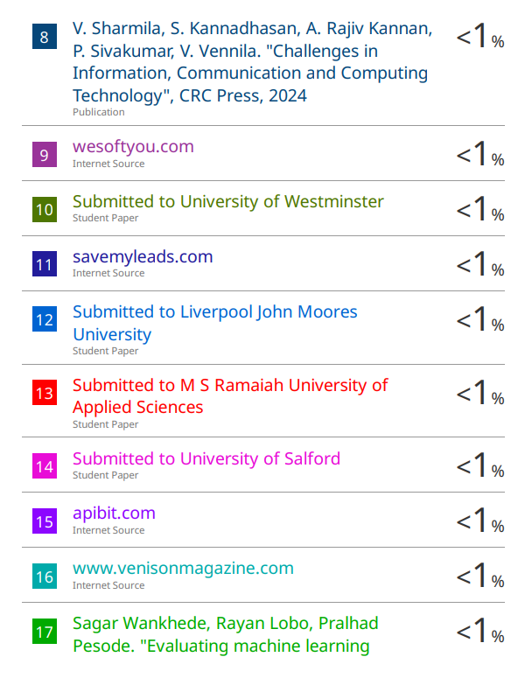

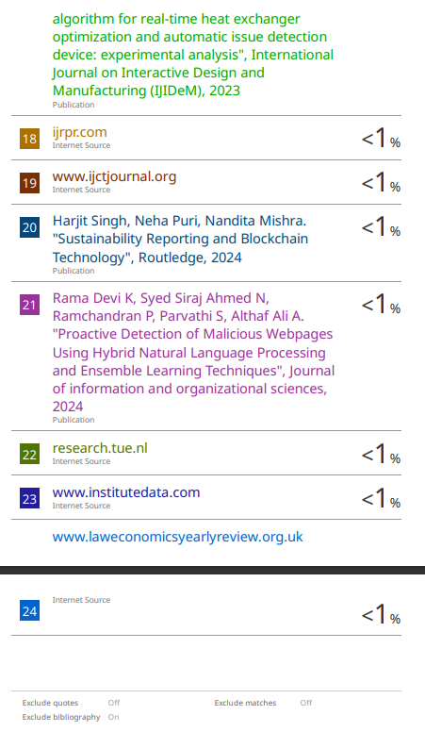

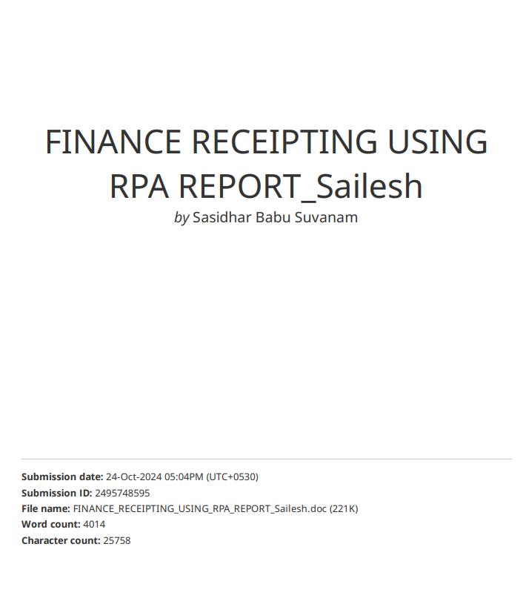

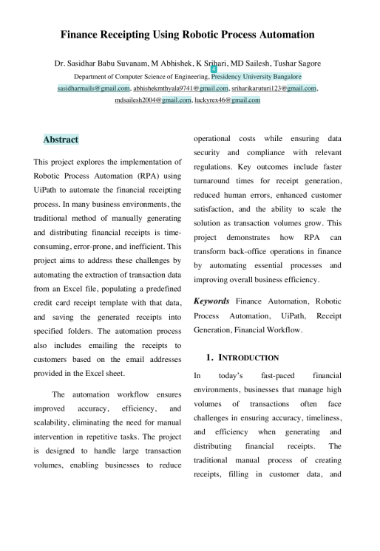

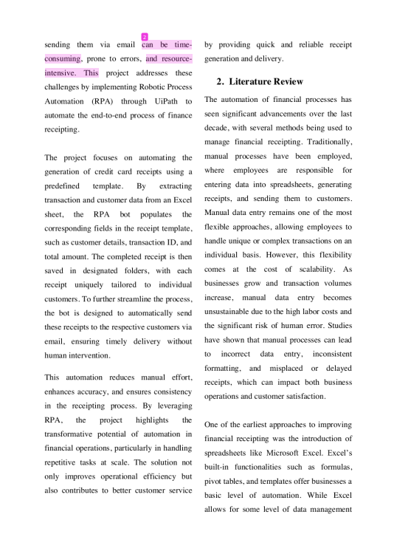

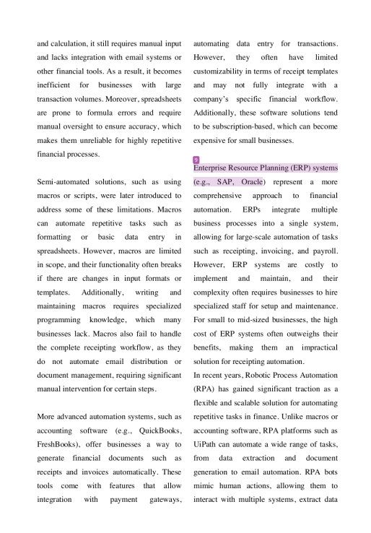

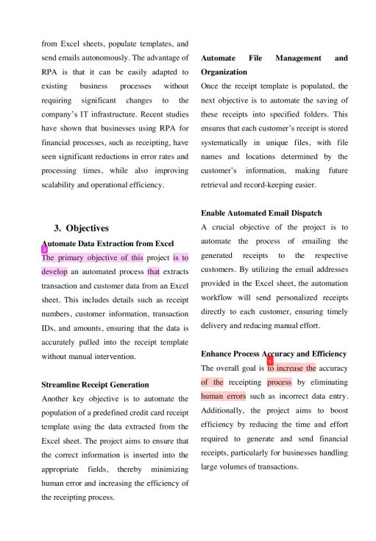

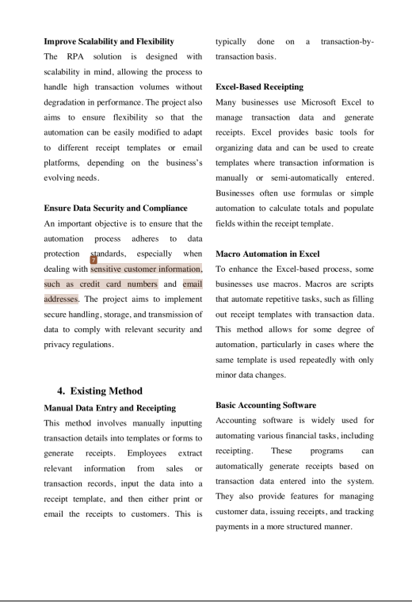

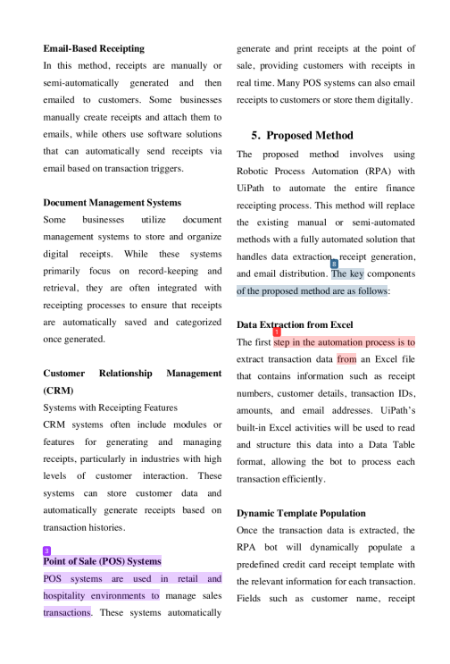

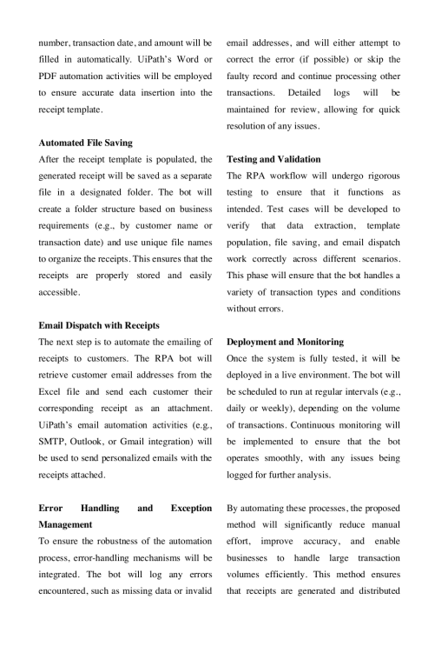

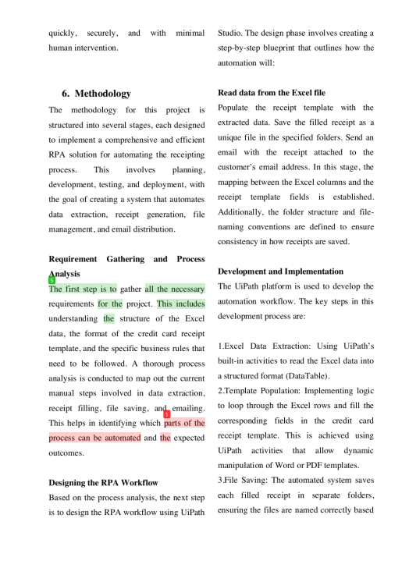

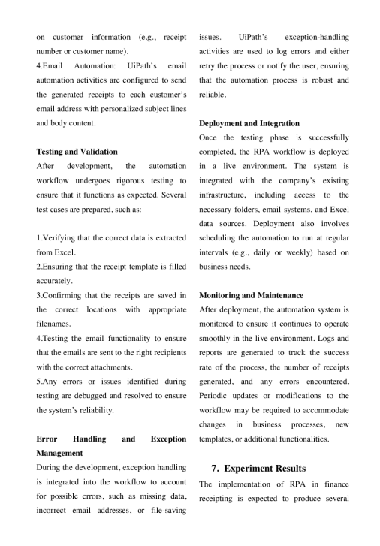

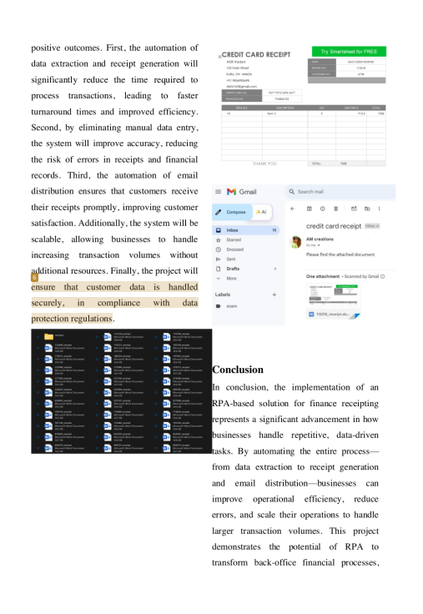

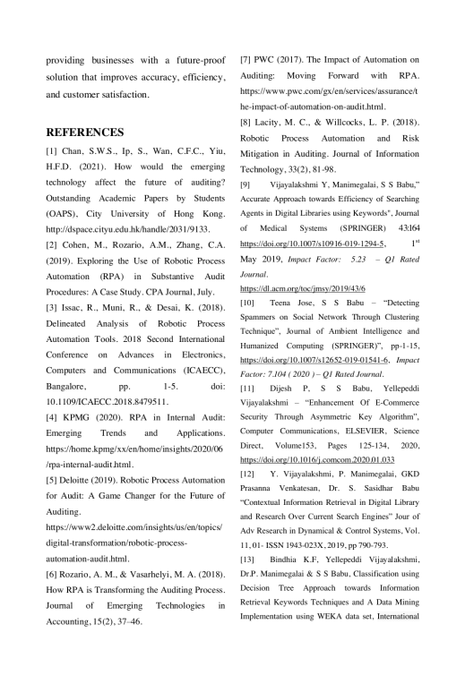

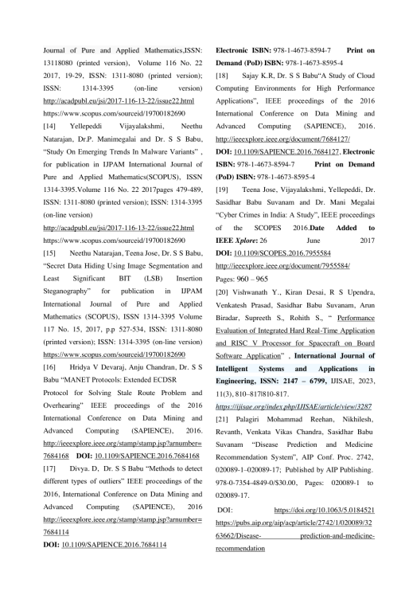

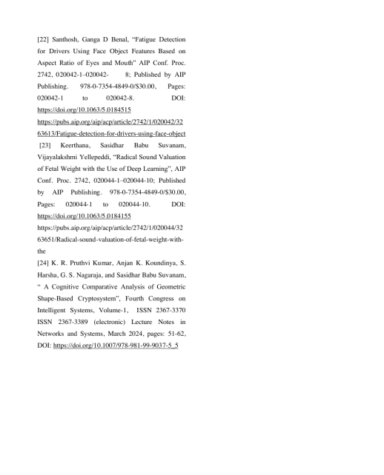

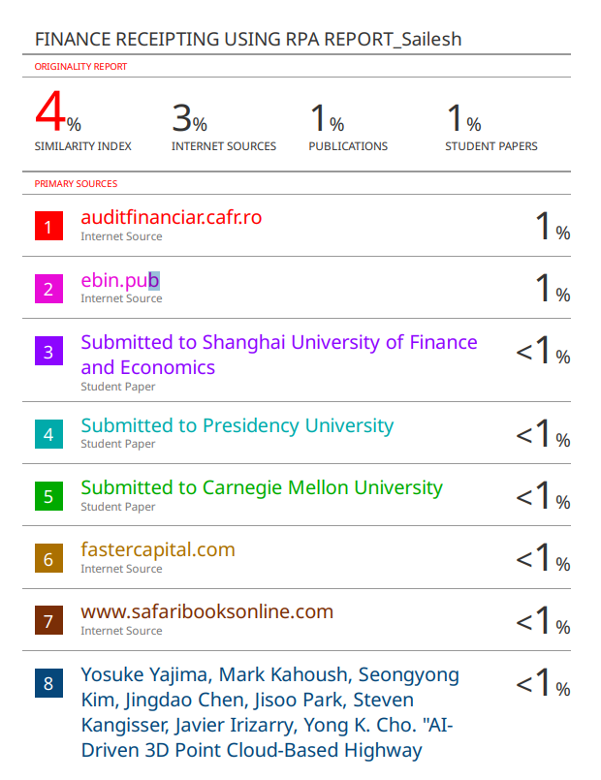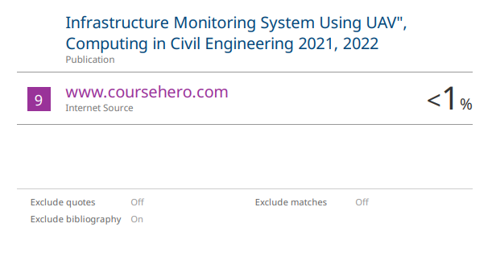

**3.****Details of mapping the project with the Sustainable Development Goals (SDGs).**

